Audit Conclusion from Audit
17/02
Support for Social Housing as Part of the Social Inclusion Policy

Key facts
In 2012-2016, CZK 61.2 billion were paid out for housing support for low-income or otherwise at-risk groups of inhabitants. Of this amount, CZK 59.1 billion were paid by the Ministry of Labour and Social Affairs (hereinafter also referred to as the “MoLSA”) and CZK 2.1 billion by the Ministry of Regional Development (“MoRD“) and from the State Housing Development Fund resources (“SHDF“).
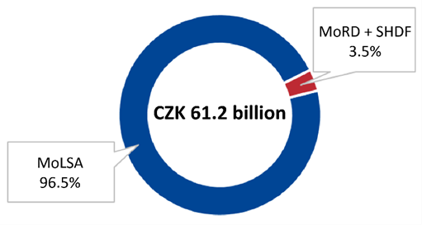
In 2012-2016, the Ministry of Labour and Social Affairs paid out CZK 40.6 billion for housing allowances, CZK 13.7 billion for housing supplements, CZK 4.3 billion for related social services and CZK 0.5 billion for social work.
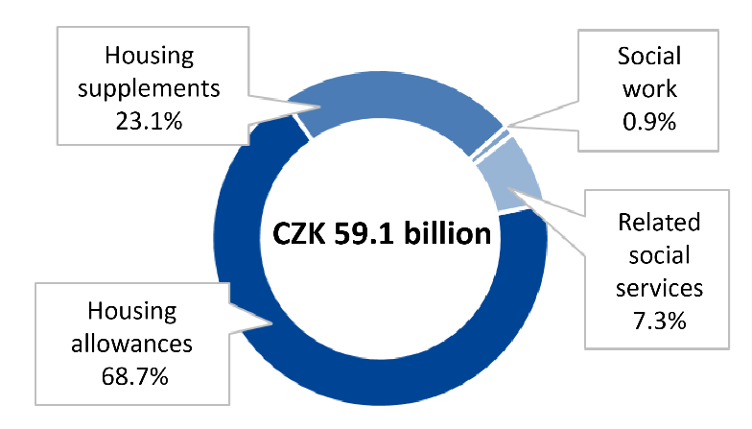
Resources spent annually by the Ministry of Labour and Social Affairs on audited interventions grew by 68.44% between 2012 and 2016.
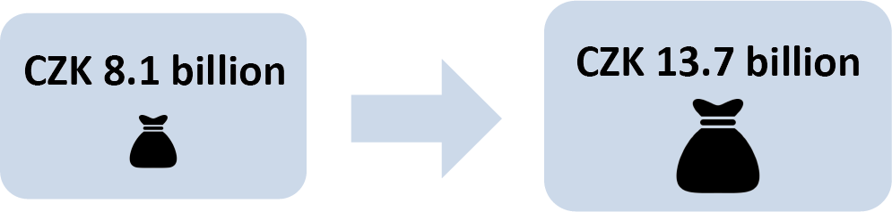
In 2012, 164 505 people on average collected housing allowances each month and 41 471 people collected housing supplements. By 2016, the number of people who collected these benefits grew to 214 960 and 64 125, respectively.
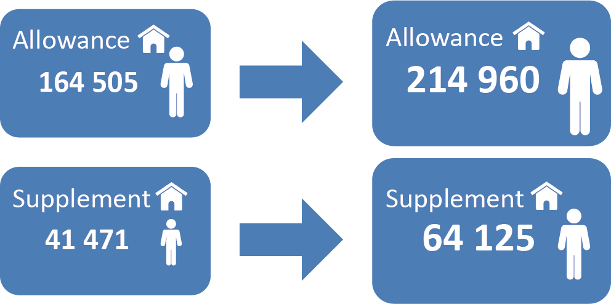
An audit conducted in 2006 shows that there were 310 socially excluded localities, in which 80 000 people lived. The next audit conducted in 2015 shows that there were as many as 606 socially excluded localities, in which 115 000 people lived. No further audits have been conducted.
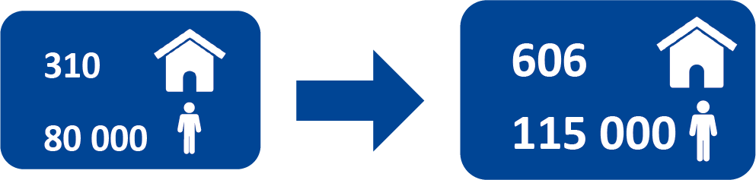

I. Introductory Information
One of the biggest social issues currently facing the Czech Republic (hereinafter also referred to as “CR”) is the social exclusion of various groups of inhabitants. Not only people housed in dormitories and shelters, youth leaving foster homes, seniors, long-term unemployed, domestic abuse victims, people living in unsuitable housing conditions and the physically handicapped are at risk of social exclusion, but so are low-income households. Homelessness is the absolute form of social exclusion. Social exclusion is most apparent in socially excluded localities (hereinafter also referred to as “SELs”). The number of such localities increased from 310 in 2006 to 606 in 2015, with the number of inhabitants living in SELs growing from 80 000 to 115 000 in the same period. This problem is most marked in the Ústí nad Labem Region, where over 40 000 people lived in SELs in 2015, which represented one third of all people living in such localities in the CR.
Preventing social exclusion is the objective of social inclusion. Social inclusion is aided by support, especially in the areas of employment, housing, education, healthcare, family and provision of social services. Arranging housing is the responsibility of the individual, not the state. However, according to the international charter of human rights and fundamental freedoms, every individual has the right to a reasonable standard of living, which includes housing. The quality of housing and its availability is one of the indicators of the standard of living within society. Loss of housing has substantial social implications and leads to social exclusion.
A wide range of entities – see Diagram 1 for more details – are involved in housing support for low-income or otherwise at-risk groups of inhabitants.
Diagram 1: Entities involved in housing support for low-income or otherwise at-risk groups of inhabitants.
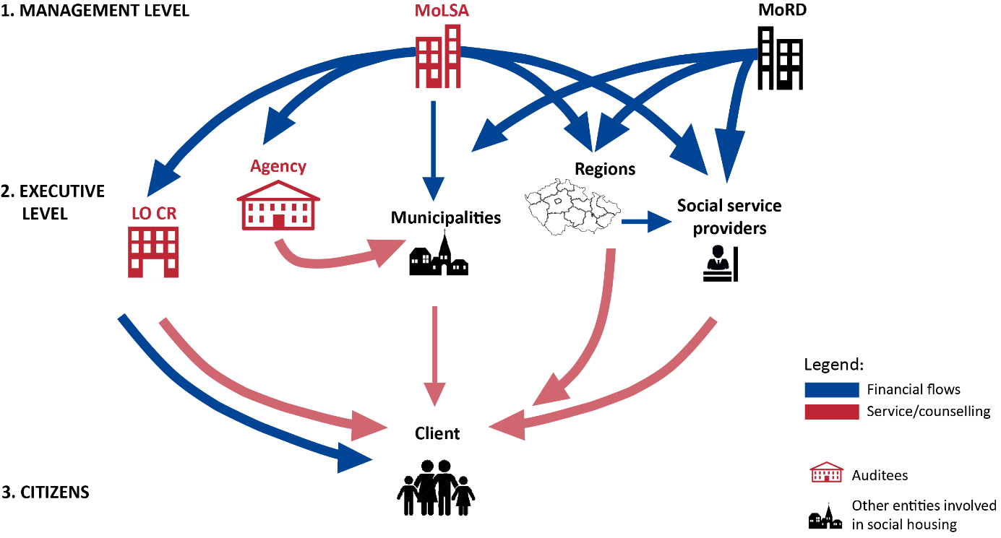
Source: Processed into the diagram by the SAO.
Interventions by the Czech MoLSA, Labour Office (hereinafter referred to as the “LO CR”) and Office of the Government (hereinafter also referred to as the “OG CR”), which authorities are involved in efforts to provide housing to low-income or otherwise at-risk groups of inhabitants, were selected to be audited by the SAO. During the audit, the SAO assessed the activities of the auditees under these interventions (hereinafter also referred to as the “audited interventions”):

- Social work – the setup and methodological management of social work by the MoLSA and activities related to social work performed by the staff of the LO CR as part of the provision of housing supplements.

- Social services – the setup and management of social services related to housing, i.e., shelters, halfway homes, dormitories, field programmes, social activation services for families with children, low-threshold treatment centres and professional social counselling (hereinafter also referred to as “related social services”), on the part of the MoLSA.

- Housing allowances and housing supplements – the setup and management of the housing allowances and supplements provided by the MoLSA and LO CR.

- Support for localities in connection with social exclusion prevention efforts – the setup, management and performance of the activities of the OG CR or its Social Inclusion Agency (hereinafter also referred to as the “Agency”) in the area of housing in selected locations where SELs exist.
During the audit, the SAO assessed chiefly the setup, management and functionality of systemic interventions executed by the MoLSA, Office of the Government and LO CR in the area of housing support for low-income and otherwise at-risk groups of inhabitants as an integral part of social inclusion policy. At the same time, it examined whether the audited interventions contributed to fulfilling the objectives of the social inclusion policy and to the effective tackling of the causes of social exclusion or the threat of social exclusion. In addition to direct efforts in the form of the auditees’ interventions, the audit examined on the system level the division of powers and responsibilities of the entities involved in housing for low-income and otherwise at-risk groups of inhabitants. Furthermore, the SAO assessed mutual cooperation among the auditees, monitored and assessed the impacts of the audited interventions and the setup and fulfilment of the objectives of the Social Housing Concept of the Czech Republic for 2015-2025 (hereinafter also referred to as the “SH Concept”), Strategy for Fighting Social Exclusion for 2011-2015 (hereinafter also referred to as the “SFSE 2011-2015”) and the Strategy for Fighting Social Exclusion for 2016-2020 (hereinafter also referred to as the “SFSE 2016-2020”).

The volume of financial resources on the system level audited for the period from January 2012 to June 2017 amounted to CZK 65.1 billion. In the 2012-2016 period, CZK 54.3 billion were spent on housing allowances and housing supplements, CZK 0.5 billion on social work, CZK 4.3 billion on related social services, and CZK 0.2 billion on the housing-related activities of the Agency. In the period from January 2017 to June 2017, CZK 5.8 billion were spent on housing allowances and housing supplements.

For the purpose of comparing the social housing system in the CR to the systems in neighbouring countries, the SAO contacted the supreme audit institutions of the Slovak Republic and the Republic of Austria in the framework of international cooperation. The details of such cooperation are described in Chapter III and in Annex 1.

Note: The legal regulations indicated in this audit conclusion are applied in their wording valid for the audited period.

II. Summary and Assessment
Existing housing support for low-income or otherwise at-risk groups of inhabitants implemented in the form of the audited interventions doesn´t contribute to effectively tackling the causes of social exclusion or the threat of social exclusion.
Support from the MoLSA is based chiefly on providing housing allowances and housing supplements. These benefits may help reduce the number of people at risk of poverty or material deprivation by compensating their insufficient income, and in certain cases thus preventing social exclusion, but they do not help tackle its causes. The audited interventions have shortcomings in their current setup and management, and these shortcomings reduce their effectiveness. The SAO’s assessment is that the audited interventions may only contribute to tackling the causes of social exclusion or the threat of social exclusion if their setup is changed, they become interlinked and they are in synergy with affordable housing support.
The audit of the interventions also showed shortcomings in their monitoring and subsequent assessment of their impacts. The SAO therefore recommends that the MoLSA initiate the setup and measuring of those indicators that allow regular assessment of the effectiveness of each intervention and its impact on social exclusion and social housing.
- Support in social housing
Social housing is not regulated in the Czech Republic by a separate legal regulation. The basic attributes of the social housing system, e.g., the term social housing itself and the target group of inhabitants for which social housing is intended, are not defined and no common system of support is in place.
At this time, a wide range of entities – both on the state administration level and on the local government level – are involved in efforts to tackle the issue of housing for low-income or otherwise at-risk groups of inhabitants. Competencies, and thus responsibility, for the issue of housing for low-income groups of inhabitants are divided among these entities. Such responsibility, however, is not clearly stipulated and applied in certain cases.
For the purpose of changing the existing state of affairs and creating a common social housing system, the MoLSA drew up the Social Housing Concept of the Czech Republic for 2015-2025, which was approved by the Government of the CR in 2015. The basic condition for fulfilment of the objectives of this concept is the adoption of legislation on social housing. At the time that the SAO concluded its audit, the bill on social housing and on housing allowance was not adopted.
An efficient and effective way of monitoring, measuring and assessing available information that would allow an analysis of the impacts of the implemented interventions in housing support for low-income or otherwise at-risk groups of inhabitants across the CR has not been created by the auditees.
- Social work
For social work to be performed in the area of material need assistance, there are no clear competencies defined in generally binding legal regulations for social workers of the LO CR or municipal offices. This situation constitutes the risk of an unsystematic and uncoordinated approach to clients who find themselves in an unfavourable situation, which is direct contradiction to the purpose of social work.
In 2015 and 2016, the MoLSA paid out regions and municipalities the total amount of CZK 550 million to support social work with the chief strategic objective of attaining an optimal number of social workers at the municipal and regional offices. These subsidies, however, did not contributed substantially to a change in the total number of social workers. In 2016, the actual number of social workers was only at 28% of the number stipulated by the MoLSA as optimal.
Even if the MoLSA is the administrator of an information system that includes a module for social work, it had limited possibilities for analysing data in the field of social work performed by social workers employed by the municipal offices and the LO CR. This situation constituted a risk for making the right strategic decisions on the way to secure such work.
Although the LO CR has gradually increased the number of its staff, there has been no long-term increase in the number of social inspections carried out. The small proportion of social inspections carried out in relation to the number of benefits paid out means a higher risk of wrongfully paid out funding.
- Social services
The MoLSA paid out a total of CZK 4.3 billion to regions to support social services in the 2012-2016 period. The MoLSA, as the administrator of the budget heading, did not, despite the existence of available information, assess the effectiveness of the subsidies it provided for social services, nor did it even assess the benefit of the subsidies for resolving housing for low-income or otherwise at-risk groups of inhabitants.
Based on available information, the SAO verified that the MoLSA paid out the greatest number of subsidies for related social services to the regions where the greatest number and amount of housing supplements was paid out each year and in which the greatest number of recipients of this benefit lived.
- Housing allowances and housing supplements
The housing allowances and housing supplements, on which the MoLSA spent CZK 54.3 billion in the 2012-2016 period, are the strongest tools used by the MoLSA to deal with housing emergencies. These benefits are neither motivational nor preventive in nature, however. Their primary objective is to help keep people housed. Although the MoLSA is gradually modifying and restricting the conditions for claiming such benefits and the amount of such benefits, possibilities for overusing the provided support persist in legal regulations. The LO CR responded to the inadequacy of legal regulations by issuing internal regulations that partially compensate for this situation.
- Activities of the Agency in the area of housing
Based on the resolution of the Government of the Czech Republic, the Agency for Social Inclusion was established under the Office of the Government of the CR. The method used to guarantee the Agency’s operations is arbitrary in relation to its position, scope of powers and funding. In the area of cooperation between the Agency and local partners (municipalities and other entities), the rights and obligations of the parties have not been clearly defined. Cooperation between the localities and the Agency is voluntary. Moreover, the Agency has no powers or competencies and cannot influence the execution of measures set out in social inclusion strategic plans in the area of housing, which the local partners are responsible for. The interest on the part of the localities in working with the Agency has been falling gradually since 2012.
The Agency’s cooperation with the managing authority of the Integrated Regional Operational Programme has not been sufficient, which jeopardises the effectiveness of the Agency’s interventions on the local level and utilisation of funds from the Integrated Regional Operational Programme and the Employment operational programme and thus the purpose of the entire coordinated approach to SELs.
The proposed measures in the field of housing were implemented only in part, and this situation brings about the risk that the identified needs of SEL inhabitants will not be dealt with. With regard to valid legal regulations and the method of setup cooperation, the responsibility for tackling the causes and impacts of social exclusion on the local level lies, however, with the municipalities and other involved entities.
III. Social housing systems used in Slovakia, Austria and the CR
Unlike the CR, the social housing system in Slovakia is regulated by an act, which also defines the target group. Social housing constitutes all housing secured from public sources, i.e., council housing as well. Municipalities are responsible for providing social housing and set their own conditions based on the law. The methods used to support social housing (in the form of benefits, payments and provision of social services) are the same as in the CR.
In Austria, social housing is understood in a broader context as housing available to a wider class of inhabitants, not only for the poorest or social excluded individuals. Unlike the CR, Austria focuses mainly on supporting the construction of housing, especially affordable rental housing. In 2014, the share of households using rental housing in the total number of households living in flats was 42%. In the Czech Republic, in contrast, this share was only 21 %.
Slovakia
The social housing system in Slovakia is similar to that in the CR, especially as regards the kinds of support (material need assistance and social services). In Slovakia, however, social housing is defined by law. It is defined as housing arranged using public sources and intended for reasonable and dignified housing for individuals who are unable to arrange housing through means available to them (they are not able to “compete” on the housing market) and, at the same time, fulfil the conditions under this law, with housing quality being clearly defined. The target group for social housing is benchmarked primarily to three or four times the minimum living wage. Social housing is fully in the purview of the local governments, i.e., cities and towns, and is guaranteed through projects built using public resources (e.g., resources from the State Housing Development Fund or the Ministry of Transport and Construction of the Slovak Republic) and social service contributions (from the budget heading of the Ministry of Labour, Social Affairs and Family of the Slovak Republic).
Rental housing owned by cities and towns is thus one of the forms of social housing provided. The rules for allocating social housing are determined by the municipalities themselves. In many cases, however, these conditions – such as the need to make a financial guarantee (deposit), minimum period of time of the applicant's permanent residence in the municipality, no debts owed to the municipality) – create barriers to housing. If a municipality has no free housing, it places the applicant on a waiting list. Municipalities are not required to provide housing to each person (household) who fulfils the statutory conditions. The maximum rental period is three years, which can be extended if the conditions are fulfilled repeatedly. Just like the Czech Republic, Slovakia faces a shortage of council rental housing, and the construction of such housing shows a decreasing trend. In 2012, 1 545 housing units were built in the public sector in Slovakia, whereas in 2016 only 336.
In Slovakia, housing allowance is provided as part of material need assistance to individuals. This allowance is intended to partially cover the costs of living and amounts to EUR 55.8 for single-person households and EUR 89.2 for jointly assessed individuals. Certain social services where clients are provided care along with lodging are also considered social housing. Financial contribution from the Ministry of Labour, Social Affairs and Family of the Slovak Republic is provided as a fixed amount per place in the facility per month according to the type of service.
Austria
The Austrian social housing system is not aimed only at low-income individuals/households. In fact, its aim is to give the widest class of inhabitants affordable and quality housing. This policy prevents social segregation and contributes to social reconciliation. In Austria, there is no common social housing support system. The various federal states – in cooperation with the municipalities and public benefit organisations – are responsible for social housing (each has its own social housing regulations).
As regards the method of support, in Austria, direct housing support (loans, grants, contributions) prevails over indirect support (tax relief). Support is provided either “to the building” (housing construction loan with subsidised interest or instalments) or “to the people” (e.g., housing benefits). Unlike the Czech Republic in Austria, the support of objects clearly prevails. Support provided to buildings is advantageous in that it stimulates housing construction, which contributes to balanced supply and demand on the housing market. The proportion of social housing compared to the total number of apartments in Austria is 24% (60% in relation to the rental housing sector). In this regard, Austria ranks second among the EU Member States.
Support for individuals in Austria can be divided into two types: a housing allowance according to federal state housing support laws, which is intended to support housing construction; and a housing need benefit, which is part of the system of “minimum security aimed at need”. Individuals who have “dire” need for housing can apply for the housing construction support, taking into account the amount of income and floor area. An upper limit is set for both criteria. The housing need benefit is intended for people who cannot fully cover their need for “reasonable housing”, i.e., if the reasonable costs of housing exceed 25% of the given minimum standard.
Czech Republic
In the Czech Republic, social housing is not regulated by any legal regulation. In other words, the target group is not defined either. Social housing is perceived as housing intended only for low-income or socially excluded individuals. Care for the housing needs of citizens is entrusted to the municipalities. The state provides funding for designated interventions from the MoLSA and MoRD budget headings.
State support for the construction of housing for low-income or otherwise at-risk groups of inhabitants is minimal compared to the total funds expended on support. In the Czech Republic, as a result of the privatisation of council housing, the proportion of rental housing has fallen. The proportion of households taking advantage of rental housing compared to the total number of households living in flats was only 21% in 2014, which is half the number in Austria. State support has long been focused in favour of home ownership (support for building savings, tax relief on home loans etc.), which, in connection with the rise in real estate prices (as at 30 June 2017 by about 15% compared to 2010) and stricter conditions for obtaining a home loan, is becoming less accessible to a wider class of inhabitants. Conversely, rental housing construction in the Czech Republic has been insufficient (by both the public sector and the private sector), which together with the deregulation of rent led to a rise in rent prices by 85% between 2005 and 2015.
State support is substantially aimed at the benefits system that is designed to allow people to pay for standard housing and help them not to lose it only because they get into financial difficulty. As mentioned in previous chapters, this system does not deal with the reason for the unfavourable situation arising for its clients. Social services and social work are among the other tools of support in the area of housing.

Annex 1
Social Housing Systems used in Slovakia, Austria and the Czech Republic
 | Czech Republic | Republic of Austria | Slovak Republic
Risk-of-poverty* threshold in PPS** | 7 508 | 13 514 | 6 304
Percentage of persons at risk of poverty and social exclusion*** in 2016 | 13.3% | 18% | 18.1%
Social housing regulated by legislation | No | Acts, regulations, decrees of federal states | Act
State support for social housing | Benefits system:  - Housing allowance and housing supplement  - Social services  - Social work  - Housing construction | Housing construction:  - Housing allowance  - Housing need benefit | Benefits system:  - Housing allowance  - Social services  - Housing construction

* The risk-of-poverty threshold is based on amount of income (60% of the national median equalised disposable income); absolute value different in each country. Source: Eurostat
** PPS = Purchasing Power Standard; an artificially created currency unit used in international comparisons that compares the purchasing power of each currency. It thus erases differences in price levels between countries and thus allows meaningful pure volume comparison.
*** This is a summary indicator that comprises three indicators: persons below the at-risk-of-poverty threshold, severely materially deprived persons and individuals living in households with very low work intensity.

Under Section 3(f) of Act No. 108/2006 Coll., on social services, social exclusion is understood as the “exclusion of a person from a common life within society and impossibility of integration into such life due to an adverse social situation.”
In Analýza sociálně vyloučených lokalit v ČR [Analysis of Socially Excluded Localities in the Czech Republic], a socially excluded locality is a place where more than 20 people living in unsuitable conditions are concentrated (indicated by the number of welfare recipients) and where these people occupy a physically or symbolically defined space.
More up-to-date information is not available. Source: Analýza sociálně vyloučených lokalit v ČR [Analysis of Socially Excluded Localities in the Czech Republic]; Prague, GAC spol. s.r.o. 2015. Analýza sociálně vyloučených romských lokalit a absorpční kapacity subjektů působících v této oblasti [Analysis of Socially Excluded Roma Localities and Absorption Capacity of Entities Active in this Area]; Prague, GAC spol. s.r.o. 2006.
The state implements other interventions through the Ministry for Regional Development and the State Housing Development Fund, which were not auditees in Audit No. 17/02. Nevertheless, the SAO looked into their activities in the area of housing in, e.g., Audit No. 15/18.
Administration (approval and payment) of the housing allowances and housing supplements were not scrutinised. The audit was conducted at the General Directorate of the LO CR, at its regional offices in Ostrava and Ústí nad Labem and its contact points in Litvínov and Ostrava.
The activities of the Agency in the field of social inclusion can be divided into activities on the central level (preparation and monitoring of the strategy for fighting social exclusion, contribution to setting up utilisation of funds from European Union funds, methodological activities, selection of localities for cooperation, identification of good practices and transferring of findings from the localities to the national level) and into intervention efforts in localities where it is present (contribution to SEL analysis in the locality, definition of the needs of SEL inhabitants, local partnership and working group efforts, creation, implementation and assessment of the strategic plan for social inclusion, provision of project advisory, assessment of the impact of activities). The activities of the Agency at the local level in the localities of Litvínov, Štětí, Ostrava and Osoblažsko, the impact of its interventions and its cooperation with the Ústí nad Labem and Moravian-Silesian Regions were scrutinised.
Includes funds from the State Budget and European Union Funds (projects Nos. CZ1.04/3.2.00/47.00001, CZ1.04.3.2.00/90.00001 and CZ.03.2.63/0.0/0.0/15_030/0000605).
The information in this chapter was obtained under the international Benchmarking Information Exchange Project headed by the SAO based on international cooperation carried out in accordance with Section 16 of Act No. 166/1993 Coll., on the Supreme Audit Office, and using public resources.
Source: Statistical Office of the Slovak Republic
Housing that a household spends less the 30% of its income on is considered affordable.

