Audit Conclusion

17/12

Value added tax administration

The audit was included in the audit schedule of the Supreme Audit Office (hereinafter the “SAO”) for 2017 under number 17/12. The audit was headed and the Audit Conclusion (hereinafter the “Conclusion”) drawn up by the SAO member JUDr. Ing. Jiří Kalivoda.

The aim of the SAO audit was to assess the value added tax legislation in particular in the field of e-commerce, the procedure of the tax and customs authorities in administering the tax and the effectiveness of the control system, including the impact on the revenue of the state budget.

Inspected persons:
- Financial Administration authorities: General Financial Directorate, Prague (hereinafter the “GFD”); Tax Office for the City of Prague (hereinafter the “Prague Tax Office”); Tax Office for the Moravian-Silesian Region, Ostrava (hereinafter the “MSR Tax Office”); Tax Office for the South Moravian Region, Brno (hereinafter the “SMR Tax Office”);
- Customs Administration authorities: General Directorate of Customs, Prague (hereinafter the “GDC”); Prague-Ruzyně Customs Office.

Audits were carried out with the inspected persons between 9 May 2017 and 8 February 2018.

Subject to audit was the period from 2015 to 2017; for factual context, also the preceding and subsequent periods were checked.

The audit was performed as a parallel check according to the Cooperation Agreement between the Supreme Audit Office of the Czech Republic and the Federal Court of Auditors of the Federal Republic of Germany. The results will be incorporated into a joint report.
Objections against the audit protocol submitted by the GFD, the SMR Tax Office, the MSR Tax Office and the Prague Tax Office were settled by the heads of audit groups by decisions on the objections. The appeals filed by the GFD, the MSR Tax Office and the Prague Tax Office against the objection decisions were settled by resolutions of the Board of the SAO.

The Board of the SAO at its Xth meeting held on 30 July 2018
approved by Resolution No. 7/X/2018
the Audit Conclusion in the following wording:

Key facts
Table 1 – Dispatch of goods and provision of selected services from 1 January 2015 to 30 June 2017
Transactions carried out to the Czech Republic |  | Transactions carried out from the Czech Republic
??? | EUR 55.988 million | ??? | CZK 106,813 million
Total VAT paid | VAT paid under a special scheme | Total claim for VAT deduction | Sending goods to the EU with the right to deduct input VAT
Source: GFD.

The intra-Union effectiveness of VAT audit is low

Insufficient international exchange of information and inappropriate allocation of competences among the Member States’ tax administrators result in tax administrators not being able to assess and impose tax unless the taxable person declares transactions made to the Czech Republic.

The division of powers between Member States is not appropriate

VAT collection is the responsibility of the state of consumption although most of the operations can be performed more efficiently, quickly and administratively more easily by the state where the supplier is established or registered for a special scheme.

The performance of some of the powers of the Financial Administration authorities is insufficient

The audited Financial Administration authorities performed the search and inspection activities in relation to cross-border transactions and the data reported on such transactions in tax returns to a minimum extent. The SAO identified examples of good practice in other EU countries in this area.

The introduction of a special scheme for the taxation of selected services has achieved its objectives

The special scheme has reduced the administrative burden on the tax administrator and taxable persons whose willingness to pay tax to the state of consumption has increased.

Extending the special scheme makes sense

EU initiatives aimed at simplifying tax obligations by extending the special scheme to the shipping of goods and abolishing the individual taxation thresholds in the states of consumption will contribute to a more efficient and effective VAT administration.

The inspection of imports of small consignments from third countries is adequate

The control system set up by the customs authorities is efficient and effective. It has primarily a preventive function.

Summary and evaluation

A) Administration of VAT on goods dispatched between EU countries and provision of selected services performed by Financial Administration authorities
E-commerce is a specific, dynamically developing business area that exceeds CZK 100 billion in the Czech Republic. It allows for the direct cross-border purchase of goods or the receipt and subsequent consumption of selected services by a consumer who is not required to report such transactions to the tax administrator. In these cases, the supplier, as a taxable person, must declare and pay VAT in the state of consumption. Therefore, the inspection activities as well as measures implemented by tax administrators in one EU Member State can have a direct impact on the collection of VAT in other Member States (hereinafter “OMS”).

The SAO found out the following:
- EU legislation governing administration and administrative cooperation in the area of ​​VAT has weaknesses that significantly reduce the effectiveness of the administration of this tax. The system does not guarantee that cross-border transactions will be duly taxed. This is mainly due to the inappropriate allocation of competences between individual EU countries and the lack of synergies between EU tax administrators (see the following clauses IV.2.1, IV.4., IV.2.2, IV.6.of this Conclusion).
The state of consumption is responsible for fulfilling the obligation of the taxable person to pay VAT. However, the state of consumption has a very limited opportunity to find out whether the transaction has taken place and has been properly taxed. Only the tax administrator of the state where the taxable person has its registered office or establishment (the “state of establishment”) could find the necessary facts because it has easier access to the necessary complete supplier information. However, the tax administrator of that state is interested in inspecting the transactions executed only in the situation where the VAT of that state is jeopardised. It is not established in the system to verify whether VAT has been correctly paid to the state of consumption. It is also problematic to obtain information from third parties such as carriers, shippers, electronic market (also referred to as “e-marketplace”) operators and payment service providers from OMS. The acquisition of the information held by these entities is crucial for tax administration.
EU Council Regulation on administrative cooperation in the field of VAT allows for and requires, in certain circumstances, mutual cooperation between Member States. In the special scheme (also referred to as the “MOSS Scheme”), this cooperation took place automatically, in the area of ​​sending goods and providing selected services outside the MOSS Scheme only in rare cases. This is due to the fact that tax administrators in transactions outside the MOSS Scheme do not have data that they can exchange, and there is thus insufficient checking of the correctness of tax returns.
- The introduction of the MOSS Scheme has met its objectives but there is still room for increasing the efficiency of tax administration. Some procedures lack support in legislation or are left to the state of consumption but can only be implemented to a limited extent or with difficulty (see the following clauses IV.1.2, IV.2.3, IV.3.1, IV.3.2, IV.7. of this Conclusion).
The MOSS Scheme, compared to the usual VAT scheme, allows taxable persons to more easily meet tax obligations and makes tax administrators more effective in checking the correctness of the tax. However, some processes remain with the state of consumption under EU legislation, so theoretically the necessary acts must be carried out by all 28 EU states. These acts can be done more effectively and more simply directly by the Member State where the supplier has registered in the MOSS Scheme (also referred to as the “state of identification”). As a result, the states of consumption request that the acts be made by the tax administrator of the state of identification, even if such a procedure is not sufficiently supported by EU law and can bring some negative aspects, such as not setting the timing for the tax assessment. Although the tax administrators of the states of consumption may apply directly to the taxable entity, the effectiveness of the check is limited, for example due to the difficult enforcement of taxable persons’ obligations and the language barrier.

With the increasing volume of cross-border trade, the impact of identified shortcomings will increase. The identified shortcomings are a risk to the implementation of VAT administration under the MOSS Scheme following its extension to other types of transactions, as presented by the European Commission.

- The inspected Financial Administration authorities did not fully use their statutory powers and did not always comply with legal regulations (see the following clauses IV.1.1, IV.2.1, IV.2.4, IV.3.3, IV.4., IV.6. of this Conclusion).
An important system deficiency was the lack of search for taxable persons failing to meet their tax obligations and negligible checking of the correctness of the taxation of cross-border transactions. The SMR Tax Office violated Council Regulation (EU) No 282/2011 as regards reminders of payment of tax under the MOSS Scheme, as it did not systematically inform the state of identification of the receipt of tax reminders.

- The GFD has ensured the organisational and technical security of the VAT administration in the inspected area, but minor shortcomings have been identified influencing its effectiveness (see the following clause IV.7. of this Conclusion).
Organisational and technical support does not allow for cross-check of performance reported under the MOSS Scheme with data in the domestic tax return (“TR”). The transfer of local jurisdiction and staffing of the VAT administration for non-established persons has not been positively shown in its performance, and this potential is limited compared to the MOSS Scheme.

B) Administration of VAT on imports of small consignments carried out by customs authorities
Customs regulations and procedures by the customs authorities on the import of small consignments ensure an effective and reasonable inspection of the correctness of the declared tax base. However, the procedure for the correct calculation of the duty base is administratively lengthy and resource-intensive. The SAO has not identified any deficiencies in the customs authorities’ procedures (see the following clause IV.8. of this Conclusion).

The SAO recommends:
At EU legislation level
- Strengthen the responsibilities and powers of the state of establishment or identification so as to ensure that the VAT administration procedures for B2C transactions are provided, to the maximum possible extent, primarily by that state for all states of consumption, i.e.:
- Collecting data from taxable persons (see the following clauses IV.2.1, IV.4. of this Conclusion);
- Acceptance and comprehensive processing of the tax return, including tax assessment (see the following clauses IV.2.2, IV.2.3 of this Conclusion);
- Tax collection and recovery of arrears (see the following clauses IV.3.1, IV.3.2 of this Conclusion);
- Inspection performance (see the following clause IV.5. of this Conclusion).
In the case of the enlargement of the powers of the state of establishment, introduce a fee for that state for tax administration performed on behalf of the state of consumption.
- Strengthen the rights of the tax administrator to obtain information from third parties, in particular: payment service providers, postal and courier service providers, e-marketplace operators and similar platforms (see the following clause IV.6. of this Conclusion).
- Identify the responsibility of e-marketplace operators for the correct taxation of transactions concluded through them (see the following clause IV.6. of this Conclusion).
- Set up a coordinated search for taxable persons, particularly from the state of establishment, and sharing the results of this search (see the following clause IV.6. of this Conclusion).
- Cancel restrictions on the use of the MOSS Scheme for establishments in other Member States (see the following clause IV.1.2 of this Conclusion).
- Not restrict the mandatory exchange of information within the meaning of Article 7(1) of Council Regulation (EU) No 904/2010 only to specific cases (see the following clause IV.4. of this Conclusion).

At national legislation level
- Analyse the possibility of amending Section 148 of the Tax Code and, if appropriate, propose a change to ensure that the timing for determining the tax under the MOSS Scheme is in force if the tax administrator of another Member State initiates the check (see the following clause IV.5.3 of this Conclusion).
- Introduce the obligation for non-established persons to periodically communicate to the tax administrator information on domestic transactions for the benefit of non-taxable persons, and for non-EU residents to determine the duty to have a tax representative (see the following clause IV.2.2 of this Conclusion).

At the level of the authorities of the Financial Administration of the Czech Republic
- Start a systematic search and inspection over e-commerce (see the following clause IV.6. of this Conclusion).
- Report to the state of identification the commencement of reminders from the state of consumption (see the following clause IV.3.3 of this Conclusion).
- Ensure the comparison of the TR data in the MOSS Scheme with relevant data in domestic TR (see the following clauses IV.2.1, IV.7. of this Conclusion).

Information on the inspected area

1. Taxing cross-border provision of selected services and shipping of goods
The system of VAT administration for the taxation of electronic transactions in the import of goods, the provision of selected services and the intra-Union dispatch of goods is illustrated in Figure 1.

Figure 1 – System of levying VAT on electronic sales to a non-taxable person
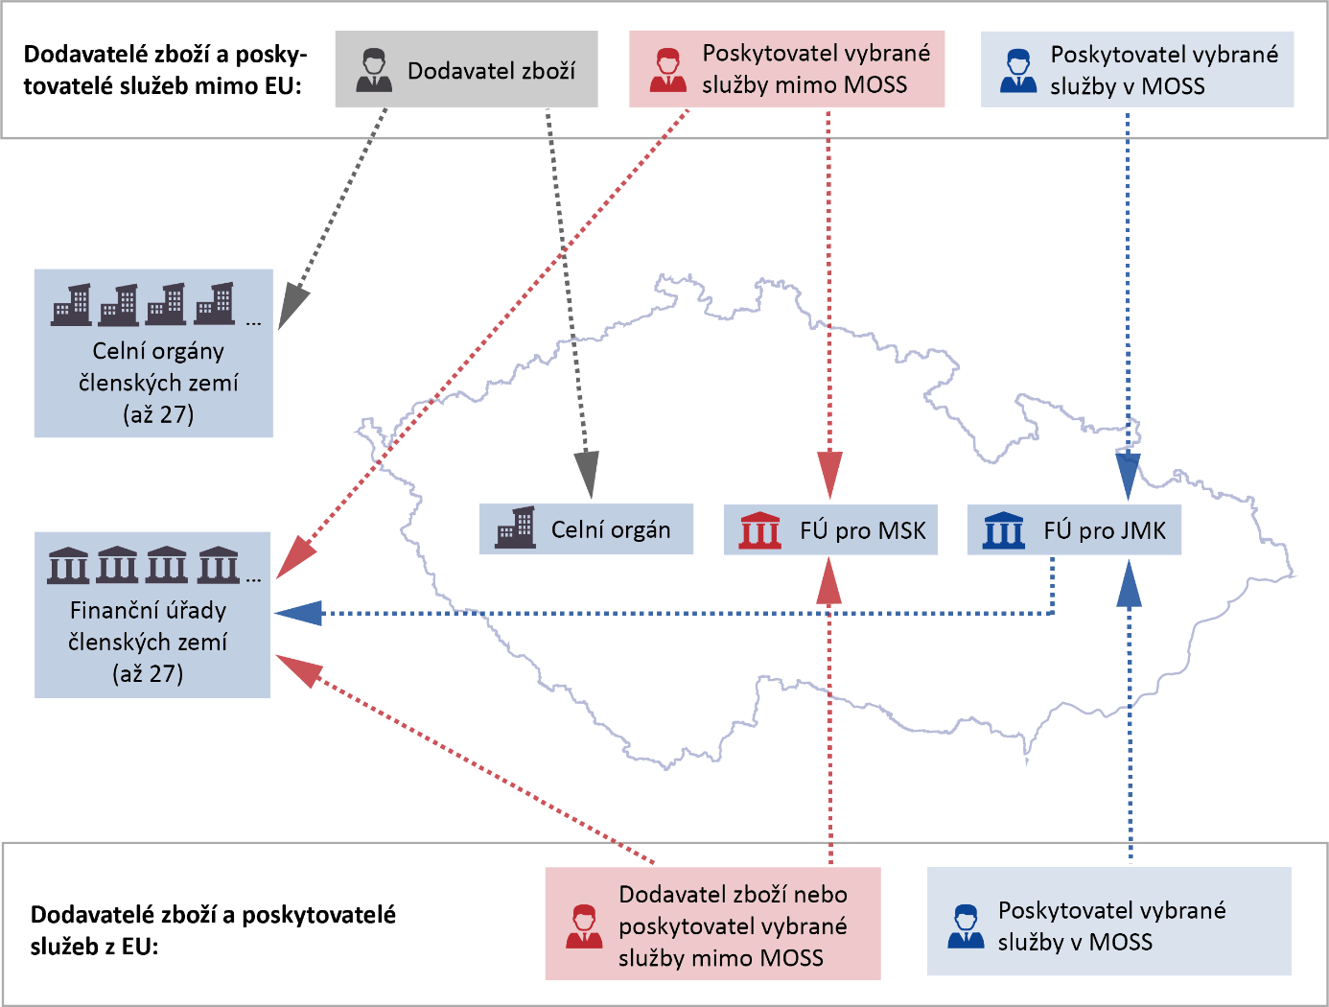
EU suppliers and service providers:
Non-EU suppliers and service providers:
Customs authorities of the Member States (up to 27)
Tax offices of the Member States (up to 27)
SMR Tax Office
MSR Tax Office
Customs authority
Provider of the selected service in MOSS
Provider of the selected service in MOSS
Supplier of goods or provider of selected services outside MOSS
Provider of the selected service outside MOSS
Supplier of goods
Source: information obtained by checking; graphically processed by the SAO.

Inspection activities in the Czech Republic are carried out by the tax authorities according to local VAT jurisdiction, which also applies to the MOSS Scheme. The administration of VAT under the normal scheme in which the taxable person is entitled to claim tax deduction from cross-border transactions is executed by the tax office designated by the person’s place of residence or registered office.

2. EU general objectives for VAT on cross-border taxation
The EU basic legal framework for VAT is Council Directive 2006/112/EC, which the Czech Republic has transposed into the VAT Act. The aim of the EU is to create an internal market. To achieve this goal, anti-competitive factors must be eliminated to the greatest extent possible. Such factors include the supply of goods and services which, under the conditions laid down by law, were not taxed. Tax administration is a procedure designed to correctly identify and determine the tax and ensure its settlement.

In the case of sending goods and providing selected services to non-taxable persons from one EU country to another, the place of taxation is the country where the goods or services are consumed. The person responsible for the tax is the supplier of the goods or the provider of the selected service. An exception to this rule is the use of the shipping tax threshold (see Figure 2).

Figure 2 – Taxation of shipping
Obligation of the taxable person

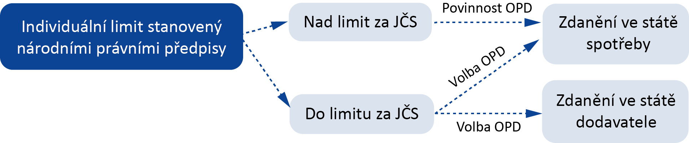
Choice of the taxable person

Choice of the taxable person

Individual threshold set by national law
Taxation in the state of consumption
Taxation in the supplier’s country
Above the threshold for OMS
Within the threshold for OMS
Source: information obtained by checking; graphically processed by the SAO.
Note: Taxable person – a person who is obliged to pay tax.
As cross-border transactions that are not subject to VAT in the country of dispatch and where the tax is to be levied as a result of exceeding the value of the dispatch threshold after a transaction in the state of consumption, the cooperation of the tax administrators in EU states is essential for the achievement of the stated objectives.

The rights and obligations of taxable persons, the tax administrator’s procedures and the cooperation of EU tax administrators are defined in the inspected area by directly applicable EU regulations, in particular Council Regulation (EU) No 904/2010 and Council Implementing Regulation (EU) No 282/2011.

3. Objectives of implementing the MOSS Scheme
Council Directive 2008/8/EC amended Council Directive 2006/112/EC. This amendment changed the place of performance when providing the selected service to OMS and introduced the MOSS Scheme. The aim of introducing the MOSS Scheme was to simplify the tax obligations of economic operators doing business in Member States in which they are not established. Selected services are the so-called electronic services, i.e. telecommunication service, radio and television broadcasting service, electronically provided service (e.g. delivery of music, games, software, hosting of websites). Simplification consists in allowing registration and filing of a tax return in the state of identification, i.e. the state where the taxable person has its registered office or establishment, instead of registering and filing tax returns in all states of consumption, i.e. the states to which the taxable person provides the selected service. The state of identification is entitled to retain a certain percentage of the tax transferred to the state of consumption (the so-called retention money).

4. Imports of goods from third countries
In the case of goods supplied from third countries to a non-taxable person, this is the import of goods to which customs legislation applies. The relevant VAT is collected by the Customs Administration authority in the context of customs clearance.

Scope of audit
Main audit questions:
- Is the VAT administration regulation for e-commerce effective, and are there significant risks for extending the MOSS Scheme?
- Are the financial and customs authorities in administering e-commerce tax in accordance with legal regulations and do they verify the compliance of taxable persons with tax law sufficiently to meet the tax administration objective?
- Are organisational and technical conditions created for effective tax administration related to the provision of electronic services?

The effectiveness of the tax administration system means the fulfilment of the objectives of tax administration within the meaning of the Tax Code, i.e. the correct identification, the assessment of taxes and their settlement, and the objectives of the EU legislation concerned. In assessing the fulfilment of the objectives of the tax administration legislation and the assessment of the application of the individual legal provisions, the SAO used, in particular, the definitions of the purpose and objectives set out in the preambles of the legislation concerned. The preamble serves as an interpretative guideline for the legally binding part of the document and is commonly used in the decision-making practice of the Court of Justice of the EU.
The SAO used the fact that the tax administrator can only proceed within the legal framework. Therefore, it reviewed the performance of the individual procedures on the audit sample for the tax administrators with the relevant subject-matter and territorial jurisdiction, using data provided by the inspected persons on individual procedures and in the framework of controlled interviews with tax administrators.

A major shortcoming is a shortcoming that has repeatedly caused the failure to achieve the tax administration objective or has such a potential. A major shortcoming is not individual misconduct of the tax administrator.

Effectiveness of VAT administration is the achievement of the tax administration objective (i.e. revenue) in obtaining the best possible ratio of the amount of administrative expenses and administrative duties of the tax administrator, e.g. per one taxable person or one TR. The evaluation criterion was a comparison with similar indicators in the administration of VAT in the normal scheme. Account was taken of the degree of electronisation in VAT administration in the MOSS Scheme and the normal scheme.

The audit was focused on verifying the system, therefore the overall inspected volume for the period from 1 January 2015 to 30 June 2017 is the value of:
- administered tax in the MOSS Scheme in the amount of EUR 81.147 million;
- dispatch of goods with a right to deduct to other Member States in the amount of CZK 106,813 million.
The amount of the assessed tax on the dispatch of goods and the provision of selected services outside the MOSS Scheme to the Czech Republic cannot be quantified.

Note: The legal regulations contained in this Audit Conclusion are applied in the version effective for the period under review.

Detailed facts ascertained by the audit

The structure of this section of the Conclusion does not fully correspond to Part I. Summary and evaluation, as the findings relate to both the regulatory area and the individual practices of the tax administrator. Deficiencies in the tax administrator’s procedures are linked to a lack of legal regulation. This section is structured according to tax administration processes.
- The registration procedure does not guarantee the correct use of the MOSS Scheme
The GFD and the SMR Tax Office have developed and applied procedures to verify the basic conditions for MOSS Scheme registration but the SAO has identified deficiencies in verifying the condition of providing the selected service and in applying the condition of non-existence of an establishment in the state of consumption. Failure to comply with these conditions significantly affects the use of the MOSS Scheme and the correctness of taxation.

The SAO verified the application of the relevant legislation on an audit sample of 184 taxable persons, i.e. 34.9 % of the total number of taxable persons registered for the MOSS Scheme in the Czech Republic.

1.1 The Prague Tax Office and the SMR Tax Office violated the legislation because they did not verify the MOSS Scheme registration condition
If a taxable person wishes to register for the MOSS Scheme in the Czech Republic, that person must file an application. The basic prerequisites for the use of and registration in the MOSS Scheme are:
- A valid VAT registration, either as a payer or as a person identified for tax purposes,
- Provision of the selected service.
The tax administrator is required to verify the information given in the application for registration and, in case of doubt as to its correctness or completeness, to ask the taxable person to explain, substantiate, supplement or change the data.

The audit revealed:
The filing of an application for the MOSS Scheme is a signal to the tax administrator of the taxable person’s effort to supply services subject to an exemption from the basic rules for determining the place of performance when providing a service to a non-taxable person listed in the VAT Act, where that exemption has an impact on the amount of domestic VAT. The tax administrator of the state of identification does not have the authority to independently authenticate TR submitted under the MOSS Scheme regulated by legislation, so registration is the best time to verify the accuracy of the use of this scheme. Explaining the terms of use of the MOSS Scheme by the tax administrator to the taxable person and the possible refusal of registration can make a significant contribution to the correctness of taxation and to the reduction of unnecessary administrative costs of a later elimination of an incorrect application of the scheme.

The SAO found that the SMR Tax Office had not verified the condition of providing the selected service at the time of registration, which resulted in the cancellation of registrations ex officio for a good reason, which was the failure to provide the selected service for at least eight following calendar quarters (see Table 2).

Table 2 – Cancellation of registration due to a failure to provide the selected service in the period from 1 January 2015 to 30 June 2017 – the Czech Republic in the position of the state of identification
527 | 7 % (35) | 5 % (25) | 22 % (40) of the audit sample
registrations in the MOSS Scheme | cancelled registrations | persons never reported the provision of the selected service | The SMR Tax Office did not verify all registration conditions
Source: SMR Tax Office.

In at least one case, the non-validation of all decisive data for the MOSS Scheme registration resulted in the registration of a taxable person who had provided and reported in the MOSS Scheme services for which the scheme cannot be used from the start of registration. As a result, the taxable person incorrectly identified the place of taxation and paid to other EU Member States a tax of EUR 21,158.14 although these services should have been taxed in the Czech Republic.

The SMR Tax Office, when registering for the MOSS Scheme, used the assumption that the verification of the conditions for the registration of a person identified for tax due to the provision of a selected service under the MOSS Scheme was made when registering it with the local tax administrator in the normal scheme. The SAO found that the Prague Tax Office had insufficiently utilised the authorisation under the Tax Code, as it had not, for persons identified for tax purposes, verified the subject of enterprise declared in the application. Of the five taxable persons who were registered as taxable persons, three asked for a subsequent registration as VAT payers, and in two cases the Prague Tax Office rejected the application. For those two entities, the SAO found that one of them had never submitted a TR under the MOSS Scheme, only registered for it, and the other had not reported any transactions in the MOSS Scheme from the tax period when it had been denied VAT registration as a payer. Both of the entities did not demonstrate economic activities and only minimally communicated with the tax administrator.

The SAO found that the SMR Tax Office had not proceeded in accordance with Section 128(1) of the Tax Code because it had failed to verify the object of the transaction for at least 40 taxable persons who had submitted an application for the MOSS Scheme registration although the object of the transaction is decisive for the registration and determination whether it is a selected service that can be taxed in the scheme. The SAO verified that, at the time of the SAO audit completion, the SMR Tax Office had already actively verified the expected object of the transaction during the registration process, and had also retroactively checked the cases of taxable persons already registered and not yet inspected.

1.2 The condition for using the MOSS Scheme, which is the absence of an establishment in the state of consumption, cannot be verified
Article 57c, first sentence, of Council Regulation (EU) No 282/2011 states: “The Union scheme shall not apply to telecommunications, broadcasting or electronic services supplied in a Member State where the taxable person has established his business or has a fixed establishment.” The interest in verifying the existence of an establishment is primarily on the part of the state of consumption because if a taxable person establishes an establishment in that state, it cannot use the MOSS Scheme there. In this case, the taxable person has to file a regular TR, and VAT income for the state of consumption is not reduced by the retention fee which the state of identification retains under the MOSS Scheme.

The audit revealed:
- The Czech Republic as the state of identification
One of the mandatory data in the MOSS Scheme application is the identification of establishments in the individual EU Member States. The SMR Tax Office, which registered about 520 taxable persons for the MOSS Scheme, did not verify the condition of non-existence of an establishment in the states of consumption.

The SAO found that if the taxable person concealed the information in the application, it was not always possible to verify the establishment information, or such verification was administratively demanding. The applicable tax administrator procedures for verifying the correctness of the data in the application for registration in the MOSS Scheme are shown in Figure 3.

Figure 3 – Verification of the correctness of the data in the registration application
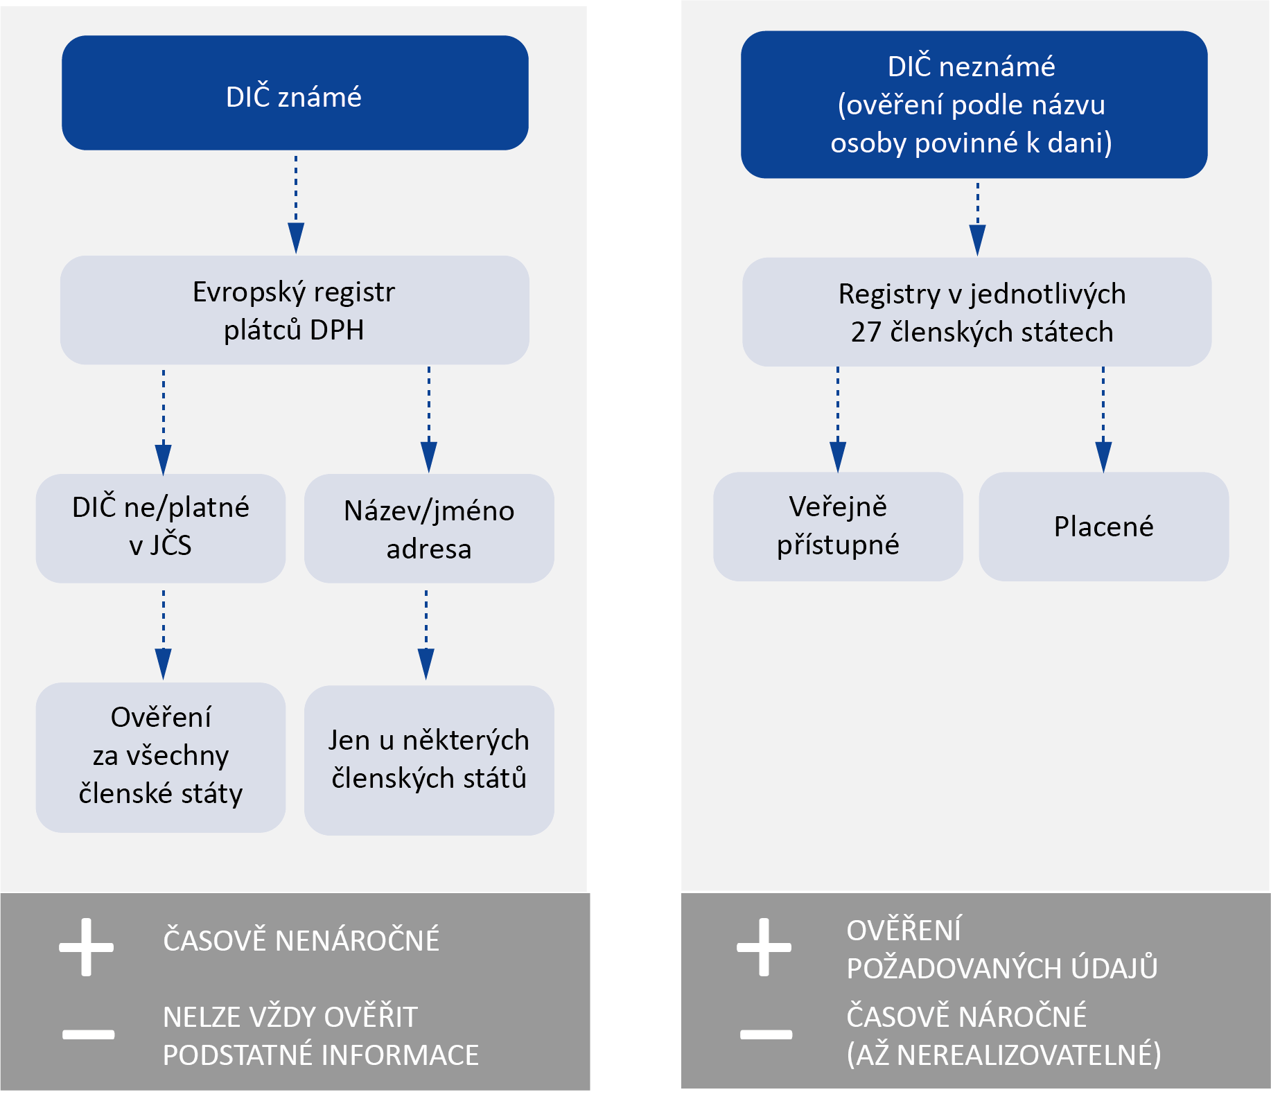
TIME NON-CONSUMING

TIME-CONSUMING (UP TO THE POINT OF NOT BEING FEASIBLE)

VERIFICATION OF THE DATA REQUIRED

SUBSTANTIAL INFORMATION CANNOT ALWAYS BE VERIFIED

Paid
Publicly accessible

Only for some Member States

Verification for all Member States

Name
Address

Tax ID No. (not) valid in OMS

Register in each of the 27 Member States

European register of VAT payers

Tax ID No. unknown
(verification by the taxable person’s name)

Tax ID No. known
Source: information obtained by checking; graphically processed by the SAO.
E.g. with the SMR Tax Office, the SAO found in one case that the taxable person had not stated the existence of an establishment in the application for registration and also had not provided data on the establishments and their operations in the TR filed. The website of that person, however, listed contact details of a branch office in Germany at the time of the SAO audit. There is thus a risk that, in the case of an establishment, that taxable person incorrectly reported transactions to Germany in the TR under the MOSS Scheme. The total amount of VAT declared for the tax period from the 1st quarter of 2015 to the 3rd quarter of 2017 was EUR 4,471,314.95, of which VAT to Germany was EUR 870,418.54. The Czech Republic retained retention money from that amount, which did not belong to it in the case of an incorrect application of the MOSS Scheme.

- The Czech Republic in the position of the state of consumption
The SMR Tax Office receives registration records from the state of identification, which it does not further check. Upon receipt of the first TR in the position of the state of consumption or in the case of special needs (e.g. refund of overpayments), an officer of the tax administrator checks the current registration data to find out about the establishment. However, this applies provided that the taxable person has reported this information to the state of identification.

If a taxable person registered with the MOSS Scheme in OMS opens an establishment in the Czech Republic as the state of consumption, then the local tax administrator assigns a Tax ID No. to that establishment. If the taxable person fails to fulfil its duty to report the establishment to the state of identification, the tax administrator of the establishment in the Czech Republic will not find out that the taxable person is registered under the MOSS Scheme in OMS.

When receiving the TR in the MOSS Scheme in the Czech Republic as the state of consumption, the tax administrator would have to verify, in the local register of taxpayers, for all taxable persons who declared VAT in the Czech Republic through the MOSS Scheme, whether they have an establishment with a Tax ID No. in the Czech Republic, thereby excluding an incorrect application of the MOSS Scheme. Due to the different Tax ID No. of the parent company and its establishment, it is possible to perform this verification through the company name. With regard to the number of TR submitted under the MOSS Scheme in the Czech Republic as the state of consumption (6,453 TR in 2015 and 10,853 TR in 2016), this would be an administratively demanding activity with an inestimable effect on the increase of the VAT income for the state budget.

The SAO notes that the condition that the taxable person’s establishment does not exist in the state of consumption is factually inaccurate because it is impossible to check using administratively reasonable activities of the tax administrator, and the relevant provision of EU law is actually effective only if the taxable persons fulfil their obligation. This may result in the misuse of the MOSS Scheme, the incorrect taxation of services provided with a reduction in VAT revenue in the state of consumption where the taxable person is established, and the creation of unnecessary expenses to eliminate such misstatements. Given that it is difficult for the tax administrator to search for establishments in OMS, the SAO recommends that the current limitation of the use of the MOSS Scheme for establishments be excluded from EU legislation. Also, after the expected cancellation of the retention money institute, this condition will be meaningless.
- Legal regulations and procedures of the inspected bodies of the Financial Administration do not ensure the correct determination and assessment of the tax
Under the Tax Code “The tax administrator ensures that the facts that are decisive for the correct determination and assessment of tax are ascertained as fully as possible, and is not bound only by the proposals of taxable entities in this regard.”

2.1 The check of the eligibility of the claimed right to deduct tax and the correctness of taxing transactions in the states of consumption (sending goods and providing selected services from the Czech Republic to other Member States) is not ensured
The set system allows the supplier in the state of establishment to claim a deduction of tax on the received transactions relating to the dispatch of goods and the provision of selected services to OMS, and thereby reduce its tax liability in the domestic TR under the normal scheme. It is important, therefore, that the tax administrator randomly verify the conduct of business transactions directed to OMS and the correctness of determining the place of taxable transactions. An important indicator of such transactions is their taxation in the states of consumption. The tax administrator, by checking the records and cash flows of the supplier, will determine the amount of transactions executed and, by checking the registration of the taxable person in OMS and the amount of the tax declared in the TR in OMS, verify the correctness of the taxation.

The tax administrator of each EU Member State is obliged to:
- Carry out, in particular, an automatic exchange of information enabling Member States of consumption to ascertain whether taxable persons not established in their territories declare and properly pay the VAT payable on selected services or the dispatch of goods;
- Inform the Member State of consumption of any irregularities which it becomes aware of;
- Without the prior request of the tax administrator of OMS concerned, provide information if the tax is deemed to be incurred in the Member State of consumption and the information provided by the Member State of establishment is necessary for the effectiveness of the control system of the Member State of consumption.

The audit revealed:
Taxable persons reported in the TR a total amount of realised transactions with the right to deduct tax on sending goods to OMS in the amount of about CZK 106,813 million (in the period from 1 January 2015 to 30 June 2017). The value of sending goods within the limit for the possibility of taxing the goods in the Czech Republic as the state of establishment and the value of selected services provided to OMS cannot be ascertained from the domestic TR because they are reported on summary lines. This is one of the reasons why, by automated comparison, it is impossible to detect the risk situation in which a taxable person in the domestic TR applies a higher value of the transactions with the right to a tax deduction than the value taxed in the particular state of consumption.

The audited Financial Administration authorities have not been able to communicate and demonstrate to the SAO the number of tax administration procedures performed to verify the alleged facts relating to the provision of selected services. Therefore, the SAO carried out, on a selected audit sample of 138 taxable persons, i.e. 26 % of the total number of taxable persons registered in the Czech Republic with the MOSS Scheme, an analysis of their procedures and compared them with the relevant provisions of the legislation. For the audited Financial Administration authorities, the SAO verified through controlled interviews and inquiries the activities of the tax administrator when verifying the eligibility of the deduction claim applied for in connection with the dispatch of goods to OMS and in verifying the taxation of the relevant transactions in the state of consumption.

The amount of claims to deduction at the input from taxable transactions received applied by taxable persons in the course of their economic activities for the purpose of performing transactions with a place of performance outside the Czech Republic cannot be ascertained from the domestic TR. The Financial Administration authorities can only ascertain such information by means of inspection procedures, but the records kept by them cannot demonstrate the frequency of these procedures in relation to the object of the SAO audit. For the audit sample, only four cases of such inspection procedures have been identified by the SAO. In one case, the Prague Tax Office found that the reported transactions had been incorrectly taxed in OMS.

Lack of information makes it impossible to internationally exchange information on transactions carried out in the states of consumption where the transaction is to be taxed even though such information exchange is required by Council Regulation (EU) No 904/2010. The audited Financial Administration authorities sent only one request for information to OMS asking whether the transactions from the CR were taxed in OMS. In the period from 1 January 2016 to 10 November 2017, the GFD received from the OMS only two requests for verification that the Czech entities did not exceed the mandatory registration threshold in these states in the case of dispatch of goods.

The MOSS Scheme allows the tax administrator in the domestic TR to check in the normal scheme the executed transactions in OMS reported under the MOSS Scheme. However, such a check is not set up systemically because the necessary TR data in the MOSS Scheme are not automatically exchanged between domestic tax administrators. The problem may also be the fact that the taxable person’s registration information into the MOSS Scheme is not automatically visible to the tax administrator in the normal scheme at the start of the check or during the check. This is because data are decentralised at individual tax offices.

The SAO found on the audit sample that, in at least 36 % of cases, taxable persons declared in at least one tax period, in the MOSS Scheme, a tax base value higher than the value given in the TR for domestic VAT. This is evidence of the fact that taxable persons did not report these transactions correctly in domestic TR in a considerable number of cases.

The GFD set up the risk profile for the identification of significant transactions and set up the inspection procedure for the tax administrator to audit the risk transaction in connection with the dispatch of goods, which was activated in total in 16 cases in 2015 and 2016. The two follow-up procedures to remove the tax administrator’s doubts on the basis of these risk profiles did not lead to tax assessment. The audited Financial Administration authorities demonstrated that the correctness of the location of the place of performance for the selected services had been verified only in one case.

The SAO notes the ineffectiveness of the provisions of Article 13(1)a) and Article 14(2) of Council Regulation (EU) No 904/2010 and non-fulfilment of the purpose of this Regulation within the meaning of the Preamble in the inspected areas. There is no mutual transfer of information relevant to the effectiveness of the inspection systems of the Member States of consumption. The risk is incorrect taxation when shipping goods and providing selected services. Tax administrators in the Member States of consumption, including the Czech Republic, have a very limited opportunity to obtain information on individual transactions and to guard against any exceeding of the limits when sending goods. The reason for this is the lack of EU legislation on the collection and exchange of data between Member States. Another reason is the role of the state of identification which, under the MOSS Scheme, only specifies the amount of the tax claimed or the difference between the last known tax and the amount newly established, but does not assess the tax. The SAO has assessed that it would not be appropriate and reciprocal under current legislation and the current state of non-transmission of information from OMS for the domestic tax administrators to actively collect this information and pass it on to OMS.

The SAO has assessed that the audited Financial Administration authorities failed to verify the decisive facts for correct tax determination and assessment, as the reported transactions with the right to deduct in electronic commerce were verified in a non-systematic manner and only in isolated cases. The Financial Administration authorities did not set up system inspection even for the MOSS Scheme, where such a form of inspection would have been possible. In assessing the state of the situation, the SAO proceeded on the basis that, if such an inspection had been carried out, the audited Financial Administration authorities would have been able to document the frequency of the inspections at least by an appropriate sample of cases.

With effect as of 1 January 2019, an annual limit of EUR 10,000 will be newly introduced to determine where the selected service will be taxed, within the meaning of Council Directive (EU) 2017/2455. Up to the limit of the services provided, the taxable person is entitled to tax those services in the state of establishment; after having exceeded this limit, they are required to tax them in the state of consumption. Only the state of identification can ascertain exceeding this limit. The SAO draws attention to the fact that this Directive requires the EU Member States to take appropriate measures to verify the conditions for the use of this limit.

2.2 The tax administrator does not have enough information to detect non-declaration of tax in the Czech Republic (delivery of goods and provision of selected services outside the MOSS Scheme to the Czech Republic)
If a person who does not have a registered office or an establishment in the Czech Republic (hereinafter referred to as the “non-established person”) does not use the MOSS Scheme in the provision of selected services, or if that person delivers goods, that person is obliged to file a TR and declare tax in the Czech Republic under the normal scheme. If the non-established person does not have to declare tax, that person does not disclose this fact to the tax administrator, i.e. the MSR Tax Office, through the TR, in accordance with the VAT Act. The failure to submit a TR tells the tax administrator that the non-established person did not execute any taxable transactions. If the non-established person does not execute any taxable transactions in the immediately preceding calendar year, the tax administrator shall cancel its registration ex officio. The procedure of the tax administrator has been audited by the SAO on the selected audit sample (see Table 3).

Table 3 – Cancellation of registration of non-established persons ex officio
44 registration files | 6 cases | 1 case | 9 submissions
SAO audit sample | cancellation of the registration ex officio | appeal | additional TR with tax declaration
Source: MSR Tax Office.
Note: These are non-established persons, registered before 30 April 2017.

The tax administrator is entitled to ask the non-established person to file a TR, but does so only if the tax administrator has doubts as to whether the taxable person has fulfilled its statutory obligation. This is only the case where the tax administrator has information or suggestions that presume that the non-established person could or should have incurred a tax liability. The source of this information is the data from inspections of other taxable persons, data from international cooperation and data from the registration procedure. The TR submission call statistics for the selected audit sample are shown in Table 4.

Table 4 – Calls for TR submission to non-established persons electronically offering goods or providing electronic services in the Czech Republic
92 non-established persons | 192 tax periods, | 19 | 100 % calls
SAO audit sample | for which no TR has been submitted | calls for TR submission | led to tax assessment
Source: MSR Tax Office.
Note: These are non-established persons, registered before 30 April 2017.

The SAO, for the audit sample of 92 electronically trading non-established persons, found that the MSR Tax Office had carried out a check only for two non-established persons in the period under review. As part of these inspections, however, the MSR Tax Office did not verify the dispatch of goods or the provision of selected services to the Czech Republic. OMS informed the Czech tax administrator about transactions that could be taxed in the Czech Republic in four cases.
The domestic TR does not allow to identify the amount of VAT attributed to goods sent to the Czech Republic or selected services provided to the Czech Republic. Non-established persons sending goods or rendering services to non-payers in the Czech Republic do not show transactions so executed on a separate line in the TR but report them together with other taxable transactions with the place of performance in the Czech Republic. Compared to other transactions, however, these transactions are not reported in other reports, such as inspection reports or VIES, which would allow the verification of their taxation without the tax administrator having to carry out the audit procedures of the non-established person. In view of the fact that the registration application or the TR do not contain more detailed e-commerce data, the tax administrator is unable to reliably identify the electronic traders by using its applications and programs.
The SAO notes that the set VAT administration system for non-established persons does not fulfil the tax administration objective to correctly determine and assess the tax because the domestic tax administrator has only limited possibilities to detect the fact that the non-established person has a duty to file a TR. This is also contributed to by the fact that the non-established person registered for VAT is not obliged to file a TR if it has not made any transactions.

The information that led the tax administrator to verify the TR was just a random finding, and therefore cannot be considered a systemic mechanism. This situation is due to the nature of e-commerce where, on the one hand, there is the merchant (non-established person) with the obligation to file a TR in another country and, on the other, a consumer who does not have any VAT obligations and therefore does not care whether tax has been paid in the state of consumption. The necessary information to identify the obligation to file a domestic TR in the Czech Republic is available in the state of establishment. However, the requesting of such information by the tax administrator is associated with difficulties (translation costs and time requirements), as only some non-established persons have representatives with powers of attorney in the Czech Republic (about 26 % of non-established persons were thus represented in the period under review). The domestic tax administrator is not able to verify the TR submitted in connection with the other activities of the non-established person (it can be expected that the person will submit the documents and records in a form corresponding to the TR). The international exchange of information on this type of transactions was quite exceptional and could not meet the objective of Council Regulation (EU) No 904/2010, which is an effective supervision of cross-border transactions.

As a result, the tax administrator does not know, in the normal scheme, what the amount of the transactions made to the Czech Republic to non-taxable persons is, and what amount of VAT has been declared in the Czech Republic. The tax administrator is unable to use the information from the OMS concerning the sending of goods or provision of selected services to the Czech Republic in an administratively simple way (e.g. through cross-checking) and compare it with the domestic TR, other reporting or the payer’s records. For verification purposes, the tax administrator would have to initiate an administratively demanding check of the non-established person with respect to all transactions reported on lines 1 and 2 of the domestic TR.

2.3 The MOSS Scheme does not guarantee the fulfilment of the condition to file a tax return
In the MOSS Scheme, the taxable person is obliged to submit the TR in any case, i.e. even for a tax period in which it did not provide any selected services. The mechanism for enforcing the obligation to file the TR under the MOSS Scheme is regulated by law and allows for several of the situations outlined in Figure 4.

Figure 4 – Enforcement of the taxable person’s obligation to file a TR
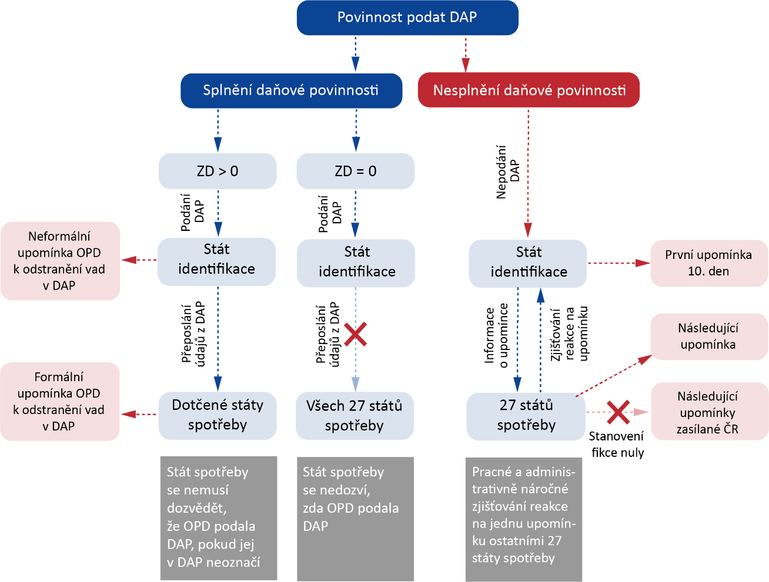
Fulfilment of tax obligations
Subsequent reminders sent by the Czech Republic
Establishment of the reminder response
Reminder information
Failure to submit TR
TR submission
TR submission
Forwarding TR data

Forwarding TR data

Determination of zero fiction
Practical and administratively demanding establishment of the response to one reminder by the other 27 states of consumption

The state of consumption will not know whether the taxable person has filed a TR

The state of consumption may not know whether the taxable person has filed a TR unless the taxable person has indicated the state of consumption in the TR

Failure to meet tax obligations
Obligation to file TR
Subsequent reminder
First reminder
10th day
Informal reminder to the taxable person to remove defects in the TR
Formal reminder to the taxable person to remove defects in the TR
States of consumption concerned

All 27 states of consumption

27 states of consumption

State of identification

State of identification

State of identification

TB = 0

TB > 0

Source: information obtained by checking; graphically processed by the SAO.
Note: TB – tax base; taxable person – a person who is obliged to pay tax.
The SMR Tax Office issued a total of 449 TR reminders as of 12 September 2017 in the position of the state of identification, with 19 % of those reminders remaining unanswered.
If the tax administrators of all states of consumption strictly sent reminders to submit the TR or calls to remove defects in the TR submitted to taxable persons, they would be burdened by repeated responses to all states of consumption. Conversely, in case that the states of consumption do not remind a taxable person to submit the TR, no one will further demand the fulfilment of that obligation because the state of identification has no such obligation or authority.
The SMR Tax Office in the position of the state of consumption verified the accuracy of the TR submitted under the MOSS Scheme only in cases where it identified obvious misstatements (such as incorrect exchange rate or incorrect tax rate). Subsequent post-tax check did not take place, and only in two cases the inspection by the state of identification was joined.
The SAO notes that the system for sending reminders to file TR under the MOSS Scheme does not fulfil its function because it does not allow the tax administrator in the state of consumption to identify all taxable persons who have not fulfilled their TR obligation in the territory of that state. The reason for this is that EU law limits the competence of the state of identification to enforce the obligation to submit the TR and check it.
In the Czech Republic, in the position of the state of consumption, the problem is further supported by the applied self-assessment system under the MOSS Scheme, defined by the VAT Act, which does not require the SMR Tax Office to monitor the TR submission and send reminders.
In the Czech Republic, the inspection activities of the SMR Tax Office as the state of consumption in the case of TR verification under the MOSS Scheme where VAT was declared in the Czech Republic was negligible, as this tax office has a very limited possibility of doubting the correctness of the TR filed. Such a doubt could be had by the state of identification if the state of identification had the authority and duty to perform such a systemic check.

2.4 The SMR Tax Office did not provide the decisive facts for the assessment of tax in another Member State
The tax administrator is obliged to transfer information to OMS without prior request if there is a risk of tax loss in that state.
The audit revealed:
The SMR Tax Office in one case violated Article 13 of Council Regulation (EU) No 904/2010 by failing to send information to the state of consumption, even though it could have assumed that there was a risk of tax loss in that state in the amount of EUR 64,299.27. The taxable person filed the TR under the MOSS Scheme even though it was not registered under that scheme at the time of filing. The tax administrator rejected the TR in the MOSS Scheme and notified the taxable person of its obligation to register and file a TR in the state of consumption.
The SAO notes that, in this case, the SMR Tax Office acted contrary to the purpose and aim of Council Regulation (EU) No 904/2010 to ensure effective and expedient mutual administrative cooperation. As a result, tax evasion in the state of consumption may have occurred (this impact cannot be verified from the position of the SAO).
- Enforcing the payment of tax in the MOSS Scheme through the state of consumption is inefficient and administratively demanding
The tax payment mechanism and procedures applied in the event of non-payment are set by EU law. Compared to normal VAT, where all recovery phases are carried out by the participating Member States, the individual MOSS Scheme phases are divided between the state of identification and the states of consumption – see Figure 5.
Figure 5 – Enforcement of tax payment from the taxable person under the MOSS Scheme
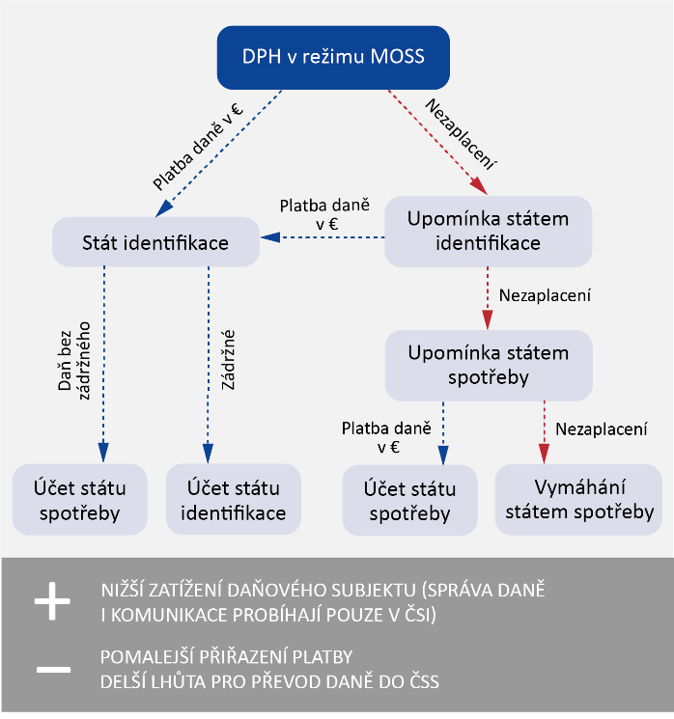
SLOWER PAYMENT ALLOCATION
LONGER TIME FOR TRANSFER OF TAX TO MSC

LOWER BURDEN ON THE TAXABLE ENTITY (TAX ADMINISTRATION AND COMMUNICATION IS EXECUTED ONLY IN THE MSI)

Tax without retention money

Non-payment

Non-payment

Non-payment

Tax payment in EUR

Tax payment in EUR

Retention money

Tax payment in EUR

Recovery by the state of consumption
State of consumption purpose

State of identification purpose

State of consumption purpose

Reminder by the state of consumption

Reminder by state of identification

State of identification
VAT in the MOSS Scheme
Source: information obtained by checking; graphically processed by the SAO.

The state of identification sends to the states of consumption, together with the tax payments, the so-called payment schedule, which sets out the identification data needed to assign individual payments to the relevant TR.

The audit revealed:

3.1 Reminding payments from the position of the state of identification is effective
The set reminder system from the state of identification is fully automated and makes it possible to send reminders by one tax administrator for all the Member States concerned, which thus do not have to do anything to send the first reminder and collect the tax. Similarly, the taxable person communicates with only one tax administrator in its official language and makes only one payment. The SAO verified the application of the legislation in question on an audit sample of 10 taxable persons with the highest arrears and did not find any deficiencies in the procedure of the SMR Tax Office. The overall success rate of reminders is shown in Table 5.

Table 5 – Statistics of payment reminders in the Czech Republic as the state of identification as of 23 June 2017
EUR ??? | 158 | 89 % | EUR 204,630
total amount of arrears – cannot be ascertained | reminders | reminder responses | total amount of arrears to recover by the states of consumption
Source: SMR Tax Office.
Note: Arrears overdue of up to three months amounted to 87 % of the total arrears.

The SAO notes that in cases where steps are taken to recover the arrears by the state of identification, the procedures are effective. The system of reminders from the state of identification reduces the administrative burden on both the tax administrator and the taxable persons, since only 11 % of the reminders were not responded to.

3.2 Reminding payments from the state of consumption creates unnecessary administrative acts
Table 6 – Arrears in the Czech Republic as the state of consumption as of 23 June 2017
EUR 2,935,282 | EUR 2,846,369 | EUR 3,648 | EUR 85,265
total arrears | unprocessed payments from the UK | arrears in case of erroneous registration in Ireland | remindable arrears
Source: SMR Tax Office.
Total amount of arrears (see Table 6) includes unprocessed payment schedules of 2015 (seven) and 2017 (three) sent from the United Kingdom of Great Britain and Northern Ireland and arrears of taxable persons wrongly registered in Ireland, including related interest. In these cases, the SMR Tax Office identified problems with assigning payments. For this reason, they did not send the reminders and waited for the settlement of the problem by the tax administrator in the state of identification. However, the funds received from the state of identification together with the schedules could not be transferred to the state budget in respect of unclear payments. The SMR Tax Office had to process these schedules repeatedly, which unnecessarily increased its administrative burden in the area of ​​securing the payment assignment agenda.

Furthermore, the SAO found that some of the states of identification (in particular the United Kingdom, Ireland, the Netherlands) had not been sending payment information under the MOSS Scheme within ten days of the end of the month in which the payment was received. The SMR Tax Office was thus unable to commence a reminder immediately after the expiry of the tax payment deadline and the reminder time limit in the position of the state of identification.

Preamble 6 of Council Regulation 904/2010 states: “Administrative cooperation should not lead to an undue shift of administrative burdens between Member States.”

The SAO found that, for the purposes of the MOSS Scheme, the rules on the provision of information and the transfer of monetary amounts between the state of identification and the states of consumption had been determined but not always respected by some Member States. Thus, administrative cooperation, contrary to the principle expressed in Preamble 6 of Council Regulation (EU) No 904/2010, has led to the transfer of administrative burden to the SMR Tax Office in the position of the state of consumption. The deficiencies identified are not on the part of the SMR Tax Office.

3.3 The SMR Tax Office, in reminding payments from the state of consumption, acted in violation of the law
Article 63a(3) and (4) of Council Regulation (EU) No 282/2011 states: “Any subsequent reminders and steps taken to collect the VAT shall be the responsibility of the Member State of consumption concerned. When such subsequent reminders have been issued by a Member State of consumption, the corresponding VAT shall be paid to that Member State. The Member State of consumption shall, by electronic means, inform the Member State of identification that a reminder has been issued” (this is the so-called reminder with switching). According to the first sentence of Preamble 19 of Council Regulation (EU) No 904/2010, the Member State of consumption is primarily responsible for ensuring that non-established suppliers fulfil their obligations.
The GFD has set up the following procedure to recover payments under the MOSS Scheme in the state of consumption. The SMR Tax Office did not send reminders to any taxable person with a debt less than EUR 10. For debts ranging from EUR 10 to EUR 500, the SMR Tax Office informally reminded the taxable persons outside ATIS by e-mail. There is no record of these reminders at the SMR Tax Office, and therefore the amount of the VAT reminded cannot be quantified. In the case of arrears over EUR 500, it sent electronically signed reminders for payment from ATIS (hereafter “reminders without switching”).

The SAO has verified the procedure of the SMR Tax Office on an audit sample of 20 taxable persons with arrears and on the total data on issued reminders. The state of identification was not informed of any alerts and reminders without switching, and the SMR Tax Office called on taxable persons for payment on behalf of the state of identification. As of 30 June 2017, the SMR Tax Office sent 126 reminders without switching, which resulted in at least a partial payment of the VAT less retention money left to the state of identification in 77 cases (i.e. 61 %). The overall success rate of reminders in the position of the state of consumption is shown in Table 7.

Table 7 – Statistics of payment reminders in the Czech Republic as the state of consumption as of 30 June 2017
??? % | EUR 19,665 | EUR 3,224 | 16 %
total success rate of reminders | reminders without switching | paid arrears after reminder without switching | effectiveness of reminders without switching
Source: SMR Tax Office.
The GFD has determined that the SMR Tax Office will proceed to send reminders with the switch as provided in the legislation only in cases where the taxable person’s debt is higher than or equal to EUR 1,500. The limit of EUR 1,500 has been set by the GFD with respect to the limit for international enforcement. The SMR Tax Office switched the reminder and informed the Member State of identification of the switching in only four cases. The switching reminder mechanism in relation to taxable persons registered with the MOSS Scheme in the Czech Republic was applied in some cases, irrespective of the amount of arrears, by Poland, Hungary, Croatia and the Federal Republic of Germany.

The SAO notes that Council Regulation (EU) No 282/2011, Council Regulation (EU) No 282/2011 and the relevant Council Directive 2006/112/EC do not contain any limits on the amount of arrears from which the mechanism of reminders with switching applies. The SAO notes that the SMR Tax Office did not act in accordance with Article 63a(3) and (4) of Council Regulation (EU) No 282/2011 because it reminded taxable persons without informing the state of identification. As a result of this procedure, the state budget collected VAT reduced by the retention money kept by the states of identification. The amount of the retention money cannot be quantified because it is not possible to quantify the total amount of VAT collected by the states of identification as a result of the actions of the SMR Tax Office. This is a system error.

The effectiveness of reminders and enforcement of arrears would be increased by the transfer of full responsibility for tax collection for all states of consumption to the state of identification. In such a case, the state of identification would not have to follow the law governing international enforcement, and in the individual states of consumption the threshold for arrears would not have to be met.
- VAT records are not a fully-fledged basis for detecting transactions in favour of non-payers and the audited Financial Administration authorities verified the keeping of those records only minimally
Records for tax purposes serve as a basis for the compilation of the tax return on the one hand and, on the other hand, as the basis for the officers of the tax administrator when verifying the correctness of the data provided in the tax returns submitted by the taxable person. This is an important check tool which, in terms of its substance and importance, is in the field of VAT that what accounting or tax records represent for income tax.

The purpose of Council Regulation (EU) No 904/2010 is to ensure effective administrative cooperation in the fight against VAT fraud (Preamble 4), which depends on the ability of the state of establishment to collect this information (Preamble 8).

The SAO examined whether the collection of information relevant to tax administration in OMS (the state of consumption) in cross-border transactions was ensured, while preserving the cost-effectiveness of tax administration, that is to say, the minimum cost of acquiring and processing such information for tax administration purposes. In assessing the situation, the SAO used a judgment of the Supreme Administrative Court, from which it follows that the law should regulate the right of the tax administrator to determine the form and structure of the data that the taxable person has the obligation to record or provide.

By way of comparison, as an example of good practice in the area of ​​selected products subject to excise duties, please note the provisions of Section 37(5) of Act No. 353/2003 Coll., on Excise Duties, according to which the warehouse keeper is obliged to keep records of the selected products in the structure and format according to the tax administrator’s requirements.

The audit revealed:
For selected services outside the MOSS Scheme no special management of the reported data is regulated by law. The taxable person supplying selected services is required to record these transactions in a standard VAT register together with other transactions exempt from tax in the Czech Republic with a right to tax deduction. This means that the records do not need to contain details for the determination and assessment of the tax in another Member State, as is the case with the same services under the MOSS Scheme. Unlike the MOSS Scheme, legislation does not regulate the obligation to make information available to the tax administrator in electronic form.

For selected services in the MOSS Scheme the taxable person not established in the Community or Member State of consumption is obliged to keep records of transactions covered by this special scheme. Compared to standard VAT records, these records must contain detailed information relevant for the taxation of services in the OMS, e.g.: identification of the Member State of consumption where the service was provided, type of the service provided, tax base and amount of tax due, indicating the currency used, payments credited to the account, information used to determine the place where the recipient is established or where he or she resides or usually stays. The taxable person must record the information so that it can be made available by electronic means to the state of consumption and the state of identification on request, without delay and for the individual services provided.

Legislation does not regulate the format and structure of record keeping or the electronic output format for the tax administrator. Furthermore, it is not clear from EU legislation whether a taxable person is required to provide complete records for all the states to which the services have been provided, including all related documents and cash flows, or only the data that will substantiate the correctness of the TR filed for the state of consumption concerned which made a request for access to records. Also, the mechanism of communication between the tax administrator of the state of consumption and the taxable person (language, method) is not set up by law. The SAO’s audit found that the states of consumption communicated with taxable persons in their official language, which for these persons entailed unnecessary administrative costs for translations and correspondence.

The SMR Tax Office did not request any taxable person registered for the MOSS Scheme in the Czech Republic to make the records available, or inspect its management. Likewise, no taxable person was asked to make the records available by another state of consumption. The audited tax authorities asked OMS for information on the record in two cases, but for the purposes of the income tax audit. In one case, the tax administrator received the requested data. In the second case, it was refused by the other tax administrator with a reference to non-fulfilment of Article 7(1) of Council Regulation (EU) No 904/2010, according to which case-by-case or case-specific information may be required. The purpose of this data request was to obtain information on taxable transactions in the Czech Republic through a taxable person established in OMS, under which the tax administrator would only then be able to identify specific cases.

When sending goods to OMS the person who sent the goods from the Czech Republic to OMS is obliged to keep records of the value of the goods sent, or of selecting the place of performance within the limit, broken down by Member States. Contrary to the MOSS Scheme, the legislation does not provide for mandatory disclosure of information from records in electronic form to the tax administrator of the state of consumption or the state of identification. These records are submitted by the taxable person only at the request of the tax administrator.

The audited Financial Administration authorities:
- Did not set up a systemic verification mechanism for keeping mandatory data;
- Did not verify the limit set for the choice of the place of performance;
- Were not able to submit statistics of the inspection activity which verified the obligation to maintain the statutory data required;
- Did not use the spontaneous information institute to verify the sending of goods.

The Czech tax administrator can find information important for the administration of tax in OMS, namely that the selected services were provided to OMS outside the MOSS Scheme or goods were delivered, and the amount of such transactions for a specific period, only when a thorough check of the taxable person is carried out. The general exercise of such control would burden both the tax administrator and the taxable persons with considerable administrative costs, and the general acquisition of data in this form would be uneconomic.

The SAO found that the audited Financial Administration authorities had inspected the obligation of taxable persons to keep records only sporadically and non-systemically, thus not complying with the provisions of the Tax Code.

The SAO notes that the system set-up does not provide for systematic and automated retrieval of information that could be provided to OMS, and thus does not fulfil the purpose of Council Regulation (EU) No 904/2010, which is the continuous supervision of these transactions. The requirement to verify specific cases already in the request for cooperation under Council Regulation (EU) No 904/2010 may be an obstacle to identifying transactions carried out in OMS, as the requesting state of consumption may not be able to identify specific cases. The purpose of the request is to determine the existence of specific transactions.

In light of the case law of the Supreme Administrative Court, the SAO notes that the problem is the lack of legal support for the definition of the form and structure of records management and, in particular, their disclosure to tax administrators. It is not ensured that tax administrator will receive information from the records in a form allowing its quick and easy use for tax purposes. The current situation does not meet the requirements for tax administration automation and administrative burden reduction for taxable persons.
- Procedures for inspection activities in the MOSS Scheme are insufficiently defined by law
The tax administrator is obliged to administer taxes in accordance with laws and other legal regulations and to exercise its authority only for the purposes for which that authority has been given to it by law and to the extent that it has been given.

The audit revealed:
At national level, the Tax Code regulates the inspection process itself, and the related cooperation with OMS is regulated by Council Regulation (EU) No 904/2010. The performance of inspection under the MOSS Scheme is not defined by EU legislation. The MOSS Scheme inspection procedures are governed by recommendations of Fiscalis Project Group 86 (“FPG 86”). However, these recommendations have no legal basis and are not binding on tax administrators.

In the period under review, a tax audit was performed in the Czech Republic as the state of identification for the fulfilment under the MOSS Scheme. Neither the GFD nor the SMR Tax Office as tax administrators of the state of consumption requested an inspection from OMS, and joined two inspections. The SAO examined these cases and found shortcomings in the following areas:

5.1 The state of identification does not have the power to carry out the inspection
It follows from legislation that all measures aimed at the correct identification and assessment of the tax primarily lie in the Member State of consumption. This means that the power of TR inspection in the MOSS Scheme lies in the state of consumption. Although the state of identification has a better opportunity to check all the facts for the correct determination and assessment of the tax, it is entitled to carry out the check only in cases where it determines the tax, i.e. when assessing VAT under the normal scheme and for non-Community users when assessing VAT under the MOSS Scheme.

Only information communicated or gathered in any form whatsoever pursuant to Council Regulation (EU) No 904/2010 may be used for the purposes of determining the basis of assessment or for collecting or administrative control of taxes. This means that if the tax administrator of the state of identification wishes to carry out a check even in cases where it does not assess the tax, and if the results of its investigation are to be used to determine the tax in the states of consumption, the tax administrator should ask the states of consumption concerned for consent to the check by one of the procedures pursuant to Council Regulation (EU) No 904/2010. However, the mechanism for requesting permission to carry out the check by the state of identification is not covered by this or any other legal regulation. The GFD from the position of the state of identification informed the states of consumption concerned of the checks carried out in accordance with the instructions of the FPG 86 working group via e-mail correspondence.

If the check is carried out by a tax administrator of the state of identification that was not requested to do so by law, or the taxable person does not agree to the results of the check carried out by the state of identification and, in a judicial review against the assessment of the tax, the court decides in favour of the taxable person, the state of consumption may incur costs, such as interest on the unauthorised actions of the tax administrator or costs of the judicial proceedings. However, the legislation does not address whether such expenditure will have to be reimbursed by the state of consumption which assessed the incorrect tax or by the state of identification on the basis of whose actions the error arose.

The SAO has found that inspection by the state of identification, without being requested by the state of consumption, is not regulated by EU legislation. The procedures under Council Regulation (EU) No 904/2010 are not suitable for the purpose described. The SAO notes that non-regulated procedures may be challenged by taxable persons for reasons of unlawfulness within the meaning of Section 5(1) and (2) of the Tax Code and may also constitute an obstacle to the achievement of the objective of tax administration to correctly identify and establish tax under the provisions of Section 1(2) of the Tax Code.

5.2 The tax refund mechanism does not affect the incorrect application of the MOSS Scheme
The state of identification or the state of consumption shall return any overpayments directly to the taxable person. The relevant EU legislation does not regulate any further refund conditions (e.g. no other taxes owed, refund deadline).

In one case, the Prague Tax Office carried out a check in the position of the state of identification and detected an incorrect use of the MOSS Scheme. Although the tax audit was completed on 6 September 2017, until the end of the SAO audit the competent Financial Administration authorities did not submit to OMS the results of the completed MOSS Scheme tax audit. In the states of consumption, VAT was refunded to the taxable person without the OMS waiting for information on the end of the check. The amount of domestic VAT assessed at the time the SAO audit was completed was not determined because the Prague Tax Office examined other circumstances relevant to the determination of domestic VAT, which would also take into account the results of the inspection of the TR submitted under the MOSS Scheme. This means that there may be an overpayment situation in one or more states of consumption, and in other states of consumption or the state of identification there will be a VAT underpayment (in particular due to an incorrect location of the place of performance).

National legislation eliminates the risk of non-payment of future domestic VAT by the use of the tax securing institute if the conditions for its use are met. This institute can be used by the tax administrator in cases where VAT is assessed. In the state of identification this is the domestic VAT and for non-established persons VAT in the MOSS Scheme. The tax administrator is not authorised to secure VAT in favour of other states of consumption.

The SAO notes that, in the event of misuse of the MOSS Scheme, the EU regulations insufficiently govern the refund procedure in the situation where tax is refunded by one or more states and newly assessed by other states.

5.3 Joining the inspection performed by another Member State does not interrupt the running of the time limit for the tax assessment
The tax assessment time limit shall not run from the date of dispatch of the application for international tax administration cooperation until the date of receipt of the reply to that request or the date of dispatch of the notification of termination of international tax cooperation in the matter. It is to be expected that the performance of the inspection by one tax administrator in the state of identification for all concerned states of consumption will be a time-consuming process, with a significant risk of expiry of the tax assessment time limit, given the scope of transactions.

On the basis of the OMS notification, the GFD joined, in the position of the state of consumption, two inspections carried out by the Dutch tax administration. The joining of the Czech Republic took place in the form of a response to the question whether the GFD wanted to check the transactions provided to the Czech Republic. The mechanism for joining the state of consumption to the inspection carried out by OMS for a taxable person under the MOSS Scheme is not a procedure under the legal regulation governing international cooperation in tax administration, and is therefore not an act determining the running of the time limit for tax assessment.

The SAO notes that Articles 7 to 12 of Council Regulation (EU) No 904/2010 provide for a procedure applicable to the request for inspection by another Member State (in this case the state of identification) on the basis of its information on such an intention. Such a procedure (a request for an administrative inquiry) could be an act determining the running of the time limit for tax assessment within the meaning of Section 148(4)f) of the Tax Code, however with regard to the basic principles of tax administration (principles of expediency and proportionality) it would require the domestic tax administrator to initiate the check. In the case of a tax audit of a taxable person registered with the MOSS Scheme in OMS, the domestic tax administrator in the position of the state of consumption will ask the state of identification to start the inspection (if necessary, to carry out further inspection actions), since the taxable person has its registered office, representative and all background in the state of identification. This would imply further administrative acts. The described problem would be resolved by the strengthening of the powers of the state of identification that assesses the tax, and the initiation of inspection by that state would determine the time limit for the tax assessment in the states of consumption.
- The search activities are insufficient and uncoordinated
The SAO, in assessing the performance of the search activities, used the assumption that identifying potential risk taxable persons who have not complied with their obligation to register for and declare tax in the Czech Republic is possible by actively monitoring the supply and demand of goods and services on the Internet, evaluating trends in e-commerce, verifying the business conditions of individual suppliers, identifying contacts and website operators, and then verifying their tax registration.

The audit revealed:
The GFD is aware that non-established persons are a very specific group of potential risk persons requiring a specific approach due to their nature and specific regulation in some areas of VAT administration. However, no system had been developed for the identification and verification of electronical traders. Search activity was rare in this area, and cases of violations of regulations by taxable persons were randomly detected in the context of inspection activities carried out in another matter or for another entity. The inspected persons submitted only five specific cases in the period under review in which they were scrutinising e-commerce entities, and only during 2017. In one case, the MSR Tax Office had already completed the verification and registered the taxable person in the Czech Republic due to exceeding the registration threshold as a non-established person. The SAO notes that this example demonstrates the need to set up system search.

From the outputs of the EU e-commerce Working Group within EUROFISC, it is clear that some EU Member States are actively seeking taxable persons who supply goods or provide selected services on their territory.

The example of Finland regarding payment service providers is particularly relevant in relation to the cross-border provision of selected services where a large number of low-denomination payments are made to the benefit of the provider; this is called a microtransaction. These are based on symbolic fees for visiting websites, expanding gaming options etc. Through microtransactions, up to several thousand can be credited to a provider’s bank account on a single day if the product is available worldwide. Records of payments made in particular through payment cards are essentially the only source of information from which the tax administrator can determine whether and in what amount the transaction has occurred.

The SAO found well-known websites of fifteen world e-shops and e-marketplace operators and one e-service provider. Then, at the MSR Tax Office, it investigated whether the entities operating the e-shops were registered for VAT in the Czech Republic, or whether and how they fulfilled their obligations. The MSR Tax Office, at the request of the SAO, began an investigation and identified the Internet domains, the holders of those domains and their headquarters. However, it did not find out who the operators of the e-shops or the shippers of goods or the providers of selected services were, and whether they had the obligation to pay VAT in the Czech Republic. The SAO, by its own investigation, found that some of them offered the delivery of goods to the Czech Republic, and therefore there was a real risk that the service providers or retailers of goods were not registered for VAT in the Czech Republic even though this obligation had arisen.

Under the Tax Code, the persons concerned are obliged to provide the tax administrator, upon request, with data relevant to the administration of tax. In relation to cross-border transactions, for example, this may be information about payments abroad and domestic goods transport. The inspected persons did not request any general data on taxable persons using the services of Česká pošta, s.p. or transport companies to send goods from OMS. The inspected persons did not try to establish systematic cooperation with carriers in sending consignments. As an example of good practice in the Czech Republic, a Memorandum of Cooperation between the Customs Administration of the Czech Republic and Česká pošta, s.p. or an agreement of the Customs Administration of the Czech Republic with the dominant express carrier, which allowed the customs authorities to identify risk transactions, can be mentioned.

The use of e-marketplaces allows taxable persons to evade tax contrary to the law. The legislation does not impose on e-marketplace operators responsibility for the fulfilment of tax regulations by taxable persons in connection with electronic transactions made through e-marketplaces or any reporting obligation. The Financial Administration authorities have identified the e-marketplace mechanism of dummy merchants that allows to legally avoid the tax registration threshold.

The SAO has identified good practice in combating tax fraud by e-marketplace abuse adopted by the United Kingdom, where fraud was detected consisting in non-declaration and non-payment of VAT, the use of invalid Tax ID No., or the use of Tax ID No. not belonging to the merchant concerned. According to published information⁷⁰ these measures were reflected in an increased number of VAT registrations for merchants from non-EU countries.

This includes, in particular:
- Cooperation between financial authorities and e-marketplace operators in the form of data acquisition and their analysis to identify vendors who could commit fraud;
- Cooperation between financial authorities and e-marketplace operators to intensively inform foreign vendors about their tax obligations;
- New legislation that makes e-marketplace operators liable where the vendor does not declare VAT (a certain form of guarantee);
- The power of financial authorities to require a tax representative for non-EU vendors;
- A split payment model allowing the bank to deduct VAT at the time the payment is made.

The SAO notes that the GFD, the MSR Tax Office and the Prague Tax Office insufficiently used the statutory authorisation to search for taxable persons within the meaning of Section 78(1) of the Tax Code, and thus did not ensure the fulfilment of the objective of the tax administration to correctly identify and assess tax in accordance with the provisions of Section 1(2) of that law. This assertion of the SAO is based on the findings, which show that the search activity was rare and random, although there were ways that could be used already in the period under review. The SAO recommends taking into account the examples of good practice in the tax legislation and procedures of the tax administrator. The GFD stated that it perceived the Internet search experience of other Member States as well as the acquisition of data from carriers and card companies and that it would use these tools with the commencement of the new Internet Department as of 1 January 2018.

It can be assumed that taxable persons do not trade only within two Member States. In view of this, it seems expedient to share the data obtained through the search for taxable persons within the EU, or, to conduct a search in a coordinated manner from the state of establishment of the supplier.
- For organisational and technical background of VAT administration, minor shortcomings were identified, affecting the efficiency of VAT administration
VAT administration is a set of tasks whose performance must be provided with sufficient staff resources. The number of tax administration staff is affected in particular by the complexity and set-up of procedures, the number of administrative tasks and technical equipment (in particular electronisation). Effective is a procedure that requires the smallest possible expense to implement it and achieve its goal.

When evaluating the VAT administration for non-established persons, the SAO took into account the objectives of changing the local jurisdiction from the Prague Tax Office to the MSR Tax Office. Documents for the legislative process to change the local jurisdiction of VAT administration for non-established persons were part of the GFD comments on Bill No. 243/2016 Coll. (August 2015). The change was to solve the insufficient staffing capacities of the Prague Tax Office, which in the long run did not correspond to the number of administered entities. The transfer was to be carried out at no additional cost and at the same time it was to save the funds spent on overtime and travel expenses of the staff of the Financial Administration of the Czech Republic as part of the project Help for Prague. The SAO’s assessment was based on the assumption that a change of local jurisdiction should result in a higher quality of performance, especially in the inspection procedures.

The audit revealed:
The SAO has reviewed the individual procedures and carried out a cost analysis of VAT administration in the normal scheme, in the MOSS Scheme and for non-settled payers. The expenditure detected were evaluated in relation to the most significant performance indicator, i.e. the number of TR submitted, which is quantifiable and attributable to personnel resources in all three areas. As the default indicator to evaluate the MOSS Scheme and the administration of non-established persons, the SAO chose the “normal” VAT scheme. The results of the comparison of the individual schemes are shown in Chart 1.

Chart 1 – Expenditure on one TR submitted in 2015 and 2016 (in CZK)
Source: GFD data; graphically prepared by the SAO.
Non-established persons
MOSS Scheme
Normal VAT scheme

An increase in costs per one TR filed in the normal VAT scheme is due to wage cost growth due to higher wage rates, which are naturally reflected in other areas of VAT administration.

The decrease in expenditure for the MOSS Scheme is due to the year-on-year growth of TR filed with a constant number of employees dedicated to their processing. The existing expenditure in the MOSS Scheme is increased by the problem of assigning payments sent from the United Kingdom. A positive factor increasing efficiency is the high degree of electronisation of the entire administration and the automation of most activities. The expenditures in the amount of CZK 108.87 million for the technical support of the MOSS Scheme were covered, at 85 %, by the retention money that the Czech Republic had received from VAT payments transferred to OMS.

Table 8 – Benefits of introducing the MOSS Scheme in the Czech Republic from 1 January 2015 to 30 June 2017
13 taxable persons | 5,401 taxable persons | EUR 55.988 million
from third countries were newly registered | declared tax in the Czech Republic | VAT paid in the MOSS Scheme
Source: MSR Tax Office, as of 8 September 2017.
Note: Taxable person – a person who is obliged to pay tax.

Compared to the situation shown in Table 8, no taxable person from a third country selected the Czech Republic as the state of registration for the VOES Scheme (which preceded the MOSS Scheme) before 31 December 2014.

Effective from 1 January 2021, the MOSS Scheme is to be expanded with sending goods. Thus, an increase in the number of TR submitted and the number of taxable persons using the MOSS Scheme can be expected, which will require a modest increase in personnel resources to perform this agenda. The number of taxable persons who send goods to the Czech Republic is unknown. From the Czech Republic, in 2016, goods were dispatched to OMS by 1,320 taxable persons (between 2014 and 2016, the number increased by 545 persons). TR processing in the MOSS Scheme is a fully automated, remote activity, and it is not essential which tax administrator performs it. On the other hand, the inspection activity requires close cooperation between the taxable person and the tax administrator, for example due to the necessary access to the records and premises of the entity.

In the case of non-established persons, a significant increase in the allocated personnel resources was negatively reflected in the costs. Although, between 2015 and 2016, the number of TR filed increased by only 22 %, the number of employees allocated to their processing increased by 150 %, which represented an increase in wage costs of CZK 7.9 million. Personnel resources were found by the Financial Administration authorities within the organisation and additional funds were not required. Even with another significant performance indicator in the form of control procedures, the increase in the number of employees has not been positively manifested yet (see Table 9). There is no specific technical support for administering VAT for non-established persons.

Table 9 – Changes in the number of inspection procedures for non-established persons between 2015 and 2016
−63 % | −64 % | −20 % | −43 %
local investigation | tax inspections initiated | procedures initiated to remove the doubt | completed procedures to remove the doubt
Source: prepared by the SAO from data provided by the GFD.
The SAO notes that for cross-border transactions where a foreign supplier is responsible for the payment of the tax, the MOSS Scheme is an effective mechanism that reduces the costs of both the tax administrator and the taxable persons and positively encourages taxable persons to pay tax in the state of consumption. According to the SAO, it is clear that a significant increase in the MOSS Scheme agenda can be expected. In order to obtain a comprehensive overview of the taxable person’s activity both under the MOSS Scheme and under the normal scheme, and in order to centralise the tax administration with one tax administrator, the SAO recommends to determine also in the MOSS Scheme the local jurisdiction for the tax administrator in the state of identification, i.e. the administrator who is responsible for administering the tax in the normal scheme.

Changing the local affiliation for non-established persons has not yet brought about an increase in the efficiency of VAT administration, nor does it have such a potential for the assessment procedure, as the number of TR filed cannot be expected to increase significantly. Conversely, with the MOSS Scheme extension, their number could decrease.
- The VAT administration system for the import of small consignments is effective and the performance of the activity is adequate
The SAO has reviewed the administration of VAT on the importation of small consignments to non-taxable persons. The audit focused on verifying the level of the system of analysis and evaluation of the risks related to the undervaluation of imported goods, the application of the procedures for determining the basis for calculating VAT and the effectiveness of these procedures. As 99.8 % of small consignments were imported to the Prague-Ruzyně Customs Office through Česká pošta, s.p. in the period under review, the SAO carried out audit only at that customs office and its supervisory GDC. The audit was conducted through controlled interviews, document analysis, analysis of web debates on small consignments and process performance observation.

The audit revealed:
Table 10 – Quantitative indicators of customs clearance for small consignments
615 %  (approximately 10.7 million consignments) | −56 % | CZK 3.31 | CZK 10.40
increase in imports between 2012 and 2016 | decrease in expenditure per consignment between years  2014 and 2016 | expenditure per cleared consignment in 2016 | expenditure per CZK assessed in 2016
Source: prepared by the SAO from data provided by the GFD.
Since 94 % of the consignments were exempt from customs duties and taxes, the SAO did not assess the expenditure in relation to the amount of the assessed tax and the assessed duty. The decrease in expenditure on one consignment (see Table 10) is due to the great increase in the number of cleared consignments with a steady number of customs officers. Expenditures do not include expenditures of Česká pošta, s.p., which, under a contract and stipulated conditions, assists the customs authorities in handling and checking consignments. The SAO verified the implementation of the contract and found no deficiencies.

Customs procedures and procedures for determining the basis for calculating duties and VAT are set out in generally binding legal regulations and are governed by internal regulations. Consignments are subjected to random but thorough systemic checks or, where appropriate, they are targeted on the basis of analytical activity outputs, about 20 consignments a day (i.e. about 7,300 consignments per year). The declared value of the goods is evaluated and compared with the usual price, e.g. on the web. In the event of any doubts of the customs authority as regards the proposed VAT calculation basis or the documents submitted (e.g. counterfeit bank statements), procedures are set in which the declared basis for VAT calculation is changed to a value accepted by the customs authority, or the procedure under Article 140 of Commission Regulation (EU) 2015/2447 is initiated. The number of cases where a new value for VAT calculation is proposed by the declarant is not kept by the customs office.

The high spending on the assessment of one CZK of VAT is due to the fact that the process is lengthy and administratively demanding. The customs authorities challenge and determine the basis for calculating VAT about five times per week (i.e. about 260 procedures per year) and the average duration of one such procedure is about 45 days (depending on the complexity of a particular case). It is clear from the reactions of the public on the Internet that the recipients of goods are aware of the activities of the customs authorities and that this has a preventive function.

The SAO notes that the VAT administration system for imports of small consignments is efficient and that the performance of the customs authorities is adequate. A risk to the adequacy of control can be a further increase in the number of consignments without providing sufficient personnel resources for customs clearance.

List of abbreviations used:

ATIS |  | Automated Tax Information System
CR (Czech Republic) |  | Czech Republic
MSI |  | Member State of Identification
MSC |  | Member State of Consumption
TR |  | Tax return
Tax ID No. |  | Tax identification number
VAT |  | Value added tax
e-commerce |  | Electronic commerce
e-marketplace |  | Electronic marketplace
EU |  | European Union
FPG 86 |  | Fiscalis Project Group 86 Working Group
Prague Tax Office |  | Tax Office for the City of Prague
SMR Tax Office |  | Tax Office for the South Moravian Region
MSR Tax Office |  | Tax Office for the Moravian-Silesian Region
GFD |  | General Financial Directorate
GDC |  | General Directorate of Customs
IT |  | Information Technology
OMS |  | Other Member State
Conclusion |  | Audit Conclusion
Non-established person |  | A person that does not have its registered office or any establishment in the country
SAO |  | Supreme Audit Office
Taxable person |  | A person who is obliged to pay tax
MOSS Scheme |  | Special MOSS Scheme (Mini One Stop Shop), scheme of one administrative place
VOES Scheme |  | A special VAT reporting and payment scheme for electronically provided services by taxable persons from third countries
United Kingdom |  | United Kingdom of Great Britain and Northern Ireland
Germany |  | Federal Republic of Germany
State of identification |  | The state in which the supplier registered in the MOSS Scheme
State of consumption |  | The state in which the service is actually used
State of establishment |  | The state in which the taxable person has its registered office or establishment
Reminder without switching |  | A reminder to pay the tax owed sent to the person concerned by the state of consumption, while the recipient of the due amount remains the state of identification (there is no change of the recipient from the state of identification to the state of consumption); the state of identification keeps the so-called retention money from the recovered tax and transfers the rest of the funds to the state of consumption
TB |  | Tax base

Qualified SAO estimate.
E.g. in the case of verification of the entitlement to deduction or verification of the place of performance if the tax is paid to OMS.
E-marketplace is basically a virtual place where the demand of many buyers meets with the supply of many suppliers.
Council Regulation (EU) No 904/2010 of 7 October 2010 on administrative cooperation and combating fraud in the field of value added tax (recast).
Mini One Stop Shop, i.e. the special one-stop scheme for the taxation of selected cross-border transactions.
E.g. inspection activities, enforcement of arrears, enforcement of the obligation to file a VAT return, imposing penalties for non-submission of the VAT return, checking of records.
Council Directive (EU) 2017/2455 of 5 December 2017 amending Directive 2006/112/EC and Directive 2009/132/EC as regards certain value added tax obligations for supplies of services and distance sales of goods.
Council Regulation (EU) No 282/2011 of 15 March 2011 laying down implementing measures for Directive 2006/112/EC on the common system of value added tax, as amended by Council Regulation (EU) No 967/2012 of 9 October 2012 amending Implementing Regulation (EU) No 282/2011 as regards the special schemes for non-established taxable persons supplying telecommunications services, broadcasting services or electronic services to non-taxable persons.
Business to customer – a name for business relationships between business companies and end customers.
Act No. 280/2009 Coll., the Tax Code.
Council Directive 2006/112/EC of 28 November 2006 on the common system of value added tax.
Act No. 235/2004 Coll., on Value Added Tax.
Pursuant to Section 1(2) of Act No. 280/2009 Coll., the Tax Code.
Council Directive 2008/8/EC of 12 February 2008 amending Directive 2006/112/EC as regards the place of supply of services.
Regulation (EU) No 952/2013 of the European Parliament and of the Council of 9 October 2013 laying down the Union Customs Code (recast).
Pursuant to Section 1(2) of Act No. 280/2009 Coll., the Tax Code.
E.g.: Judgment of the Court of Justice of 5 February 1963 in Case 26/62: “This view is confirmed by the Preamble to the Treaty which refers not only to governments but to peoples. It is also confirmed more specifically by the establishment of institutions endowed with sovereign rights, the exercise of which affects Member States and also their citizens” or Judgment of the Court of Justice (Second Chamber) of 20 December 2017 in Joined Cases C-397/16 and C-435/16: “Moreover, according to the case law of the Court of Justice, the preamble to a Union act may specify its content, but it cannot be invoked as a reason for departing from the provisions of the act in question...”
Pursuant to Section 110a(2) of Act No. 235/2004 Coll., on Value Added Tax.
Pursuant to Section 128(1) of Act No. 280/2009 Coll., the Tax Code.
Section 9(2) of Act No. 235/2004 Coll., on Value Added Tax.
Pursuant to Section 110p of Act No. 235/2004 Coll., on Value Added Tax.
Pursuant to Section 128(1) of Act No. 280/2009 Coll., the Tax Code.
Sections 6g-6l of Act No. 235/2004 Coll., on Value Added Tax.
Article 57c, first sentence, of Council Regulation (EU) No 282/2011 of 15 March 2011 laying down implementing measures for Directive 2006/112/EC on the common system of value added tax (recast).
Section 92(2) of Act No. 280/2009 Coll., the Tax Code.
Section 72(1)c) of Act No. 235/2004 Coll., on Value Added Tax.
Pursuant to Articles 14(2) and 13(1) of Council Regulation (EU) No 904/2010.
Line 1, line 2 or line 26 of the domestic TR.
The audit sample included all TR submitted by randomly selected taxable persons registered under the MOSS Scheme for which the SAO compared data in the TR submitted under the MOSS Scheme with data in TR submitted under the normal scheme for the period from 1 January 2015 to 30 June 2017.
This is due to the fact that in the domestic TR the received transactions are included among the ordinary transactions received with the right to deduct tax on line 40 or 41 of the TR.
Articles 13 and 14(2) of Council Regulation (EU) No 904/2010.
Line 26 of TR for domestic VAT.
“The fight against VAT evasion requires close cooperation between the competent authorities in each Member State responsible for the application of the regulations in this field.”
Article 1 of Council Directive (EU) 2017/2455 of 5 December 2017 amending Directive 2006/112/EC and Directive 2009/132/EC as regards certain value added tax obligations for supplies of services and distance sales of goods.
Pursuant to Section 101(4) of Act No. 235/2004 Coll., on Value Added Tax.
Pursuant to Section 106(4) of Act No. 235/2004 Coll., on Value Added Tax.
Pursuant to Section 135(1) of Act No. 280/2009 Coll., the Tax Code.
Electronically trading non-established persons were identified by own activities of the SAO.
On line 1 or line 2 of the domestic TR.
The VIES (VAT Information Exchange System) is an information system that allows you to share data on VAT payers registered in the EU and on the supply of goods and services covered by the summary VAT return.
Article 59a of Council Regulation (EU) No 282/2011 states: “Where a taxable person using a special scheme has supplied no services in any Member State of consumption under that special scheme during a return period, he shall submit a VAT return indicating that no supplies have been made during that period (a nil-VAT return).”
Article 60a(1) and (2) of Council Regulation (EU) No 282/2011 states: “The Member State of identification shall remind, by electronic means, taxable persons who have failed to submit a VAT return under Article 364 or Article 369f of Directive 2006/112/EC, of their obligation to submit such a return. The Member State of identification shall issue the reminder on the tenth day following that on which the return should have been submitted, and shall inform the other Member States by electronic means that a reminder has been issued. Any subsequent reminders and steps taken to assess and collect the VAT shall be the responsibility of the Member State of consumption concerned.”
Pursuant to Article 13(1)c) of Council Regulation (EU) No 904/2010.
Articles 62-63b of Council Regulation (EU) No 282/2011.
Pursuant to Article 46(1), last sentence, of Council Regulation (EU) No 904/2010.
Pursuant to Article 45(3) and Article 46(1), last sentence, of Council Regulation (EU) No 904/2010.
Automated Tax Information System.
Article 63a(3) and (4) of Council Regulation (EU) No 282/2011.
Article 18(3) of Council Directive 2010/24/EU of 16 March 2010 concerning mutual assistance for the recovery of claims relating to taxes, duties and other measures.
Source: comment on Section 100 of Act No. 235/2004 Coll., on Value Added Tax.
Judgment of the Supreme Administrative Court 2 Afs 25/2015 - 38 of 3 January 2018.
“What is not secured is the fitness of the data provided for machine processing in specific tax administration conditions, which, for reasons that the Supreme Administrative Court does not consider necessary to examine further, has decided to work with the .xml format. Simply put, the provision of a data file not only in the necessary logical and systematic structure but also in a data format that is easy to use in specific tax administration conditions (especially with regard to computer software used) is not ensured. However, this missing “above-standard” could be considered as the reason for ineffectiveness of a submission in the .pdf format only on the assumption that the relevant regulation in the Tax Code contains a formulation similar to that found in the second sentence of Section 123e(2)a) of Act No. 582/1991 Coll., on the Organisation and Implementation of Social Security, in force until 31 December 2014 (hereinafter the “Act on Organisation”). That provision states that, if a form is prescribed in accordance with this Act or in the matters of insurance pursuant to a special act on filing or other action, the filing or any other action may be made only in electronic form by sending it to the designated electronic address of the social security authority mailing room or to the designated data box of the social security authority; the filing or other action may be made in electronic form only in the form of a data message, in the format, structure and form specified by the competent social security authority. If the filing or any other action fails to comply with these conditions, it shall be disregarded; the social security authority shall be obliged to alert the person who made the filing or other act in electronic form that does not meet these conditions to that fact and to the fact that such a filing or other action will be disregarded”.
Pursuant to Section 100 of Act No. 235/2004 Coll., on Value Added Tax.
Pursuant to Article 369 and Article 369k(1) of Directive 2006/112/EC.
Pursuant to Section 100a(3) of Act No. 235/2004 Coll., on Value Added Tax.
Pursuant to Section 8(3) of Act No. 235/2004 Coll., on Value Added Tax.
Pursuant to Section 9(2) and Section 78(1) of Act No. 280/2009 Coll., the Tax Code, which states: “The tax administrator systematically identifies the prerequisites for the establishment or the duration of the obligations of the persons involved in the administration of taxes and makes the necessary steps to ensure the fulfilment of these obligations.” “The tax administrator searches for evidence and taxable entities and ascertains the fulfilment of their duties in administering taxes before and during the procedure.”
Pursuant to Section 5(1)-(2) of Act No. 280/2009 Coll., the Tax Code.
In particular Sections 85-88 of Act No. 280/2009 Coll., the Tax Code.
Under the FISCALIS programme, which promotes the international exchange of practical experience in the administration of EU countries’ taxes, work sessions were held to address the problems of the MOSS Scheme, e.g. Guidelines and recommendations relating to the audit and control of the VAT-MOSS.
Articles 60a and 63a of Council Regulation (EU) No 282/2011, Preamble 19 of Council Regulation (EU) No 904/2010.
Article 55(1)1) and 2) and Article 56 of Council Regulation (EU) No 904/2010.
Article 63(1)-(4) of Council Regulation (EU) No 282/2011.
Pursuant to Section 167(1) of Act No. 280/2009 Coll., the Tax Code.
Pursuant to Section 148(4)f) of Act No. 280/2009 Coll., the Tax Code.
Act No. 280/2009 Coll., the Tax Code.
EUROFISC is a unified system for the exchange of information between individual EU Member States.
Latvia – the financial administration has created a database of 1,600 domains and 3,050 entities to verify whether they are registered for tax purposes in Latvia. Latvia also monitors the market for pirate television, which is estimated to be used by more than 100,000 households, and for which an estimated tax loss of EUR 12 million per month is calculated. Finland – tax authorities receive data on executed transactions from Finnish card and payment companies by law. These are bulk records of all card payments to Finnish merchants (regardless of the payment card issuer). Annually, these amount to about 31 million bulk payment records. These data are used for general search activity, the detection of revenue concealment etc. Furthermore, the financial administration has 30-33 million records of Finnish payment cards used on the Internet per year. These records are primarily used to identify merchants exceeding the threshold of EUR 35,000 for shipping goods without registering for VAT in Finland as well as merchants who provide electronic services to Finland to non-taxable persons (analogously to Section 10i of Act No. 235/2004 Coll.) and who were not registered under the MOSS Scheme in their state of identification, i.e. directly in Finland in case of non-use of the MOSS Scheme. Bulgaria – a dedicated e-commerce monitoring team was set up in 2012. During the years 2012 to 2015, a partnership was established with shipping companies that provide data on the shipments made. The members of this team have created tools and criteria to identify risk entities suitable for inspection. The e-commerce inspection department is currently also performing e-audit, e-commerce control in general and dedicated IT search activity. Denmark – in 2016, it established a new Anti-Fraud Unit, which monitors 15,000 DK domains and domains with a Danish IP address, Danish text or Danish registrar per month. Through risk analysis, the members of this unit choose domains for further checks whether they have a Danish VAT ID etc., identifying some domains as fake trades; these cases are forwarded to the police.
Pursuant to Section 57(1)-(6) of Act No. 280/2009 Coll., the Tax Code.
Source: Information from the inspection report on VAT not paid from the sale of goods under e-commerce by foreign vendors (or non-UK residents); the report was published in April 2017 by the National Audit Office of the United Kingdom.
Pursuant to the provisions of Section 93a(2) of Act No. 235/2004 Coll., on Value Added Tax, the MSR Tax Office is locally competent for the administration of VAT for non-established persons as of 1 September 2016. The Prague Tax Office handed over this agenda, except 18 active non-established persons, by 31 August 2017.
Act No. 243/2016 Coll., amending certain laws in connection with the adoption of the Customs Act.
The procedure for calculating the administrative expenses of the administration of VAT using the wage costs expended on the staff of the assessment departments of the Financial Administration of the Czech Republic: - PZ_{DPH} = z₁ ₊ z₂ + ....... + z₃₉₇₉ where: PZ_{DPH} – the number of employees of the assessment departments directly administering VAT under OSIRIS as at 31 December 2016. z – individual shares of 3,979 systemised points (tax offices and specialised tax office) for VAT-related activities – assessment. - k = PZ_{DPH}/PEP * 100 where: k – the conversion coefficient, which represents the percentage of the number of employees of the assessment departments directly securing the administration of VAT on the total number of employees of the assessment departments. PEP – the recalculated number of employees of the assessment departments of the Financial Administration of the Czech Republic. - PPZ_{DPH} = PEP/100 * k where: PPZ_{DPH} – recalculation of the staff of the assessment departments – VAT administration. - PMV = MV/PEP where: PMV – average wage costs per employee. MV – total wage costs. - MV_{DPH} = PMV * PPZ_{DPH} where: MV_{DPH} – recalculated wage costs of assessment departments – VAT administration.
The SAO did not verify the economy and legality of the ATIS expansion by functions related to the MOSS Scheme.
VOES – a special VAT reporting and payment scheme for electronically provided services by taxable persons from third countries.
Commission Implementing Regulation (EU) 2015/2447 of 24 November 2015 laying down detailed rules for implementing certain provisions of Regulation (EU) No 952/2013 of the European Parliament and of the Council laying down the Union Customs Code.

